Prologue

Hello and welcome, people of the world!

I’m sorry to inform you, but it seems that you’re not the winners of 3 750 000 $ from the random lottery of Microsoft, Apple, or whichever corporation is trying to take your money.

This is not spam or a hidden virus. I don’t need your personal information, and I will not ask you to buy products or threaten your loved ones if you don’t share this in the next 10 seconds. This is my life’s work.

Realizing the immense power of the Internet to connect people, I’ve decided to broadcast it this way – virtually, digitally, free for all sides, and unburdened by any conditions. My only desire is, by reaching as many people as possible, to share this labor of love for all of humankind that I have, and to present you with an idea for the development of a worldwide society that focuses on respecting the social structure through respecting every individual (both of which need sufficient attention and care for a happy and functioning community to thrive). Of course, this is not obligatory, but more like one human being asking another to please give a little of your time and attention to this text. Save it and read it at your convenience – when you want and feel like it. Read it with a smile on your face as a comedy, science fiction, or serious work – it’s your decision. I’m not going to put any genre or other frames on your perception. I promise the read will be worth it because it presents a critical view of our society and the mentioned alternative to the current course of action that drives our development forward. I think that people are mature enough as a species to at least give it a look, think this over and discuss it, laugh at how detached from reality it is, or feel a tiny bit of hope in their lives and welcome it because the future can be bright if we let it and if we prepare for it in the present. The point of my work is to show you that this is possible and, with the right mindset - absolutely achievable.

Let’s start with the reason for the existence of this text so that you can gain more insight into its inspiration and goals. It’s quite simple, actually. As a normal human being, I care about our society – that of people and all other living things on Earth. I’m noticing that throughout history, despite all the suffering and misery in our existence, one undertaking has managed to break the chains of time and continue to develop and grow exponentially, fueled by the omnipotent human spirit, our limitless curiosity, and desire to unravel the inner workings of our world – the study and development of science and technology. Recently it helped us overcome many obstacles in communication to the point where today, I can reach all of you with just a couple of clicks at my convenience. But as before, that spirit cannot rest and needs constant movement, progress, and development towards a better tomorrow “from the primitive through the complex towards simplicity” (Wernher von Braun). Our time has its own problems which are more and more easily visible exactly due to the level of connection we have nowadays. Tuning in to the voices of the people, it becomes clear that there is ubiquitous and oppressive corruption, misinformation and dumbing down, shadow governments, rigged elections, uneven and unfair distribution of resources and responsibilities, criminal organizations masquerading as multinational companies, suppression and devaluation of revolutionary breakthroughs and ideas that aren’t part of their plan and cruel practices of brainwashing not just in secret facilities for espionage and creating “sleeper agents,” but also on the billboards, news outlets and screens of our electronic devices creating artificial divisions and encouraging greed, lust, and pride. All of this is aimed at sustaining a society that is obedient to the status quo and to the vicious cycle of living at a lower plane of existence - closer to mindless drones operating on instinct and in blissful ignorance of our inner workings and those of the world rather than actual sentient beings that constantly questions their environment as is our nature. I’m not one to easily pass over the fact that almost every 3.6 seconds, someone starves to death in some parts of the world, while in others, the stores are filled with surplus food, and people can order freshly cooked meals that arrive in less than an hour. The debate on news outlets about which party will be next in line and why the current one didn’t fulfill most of its pre-election promises seems endless. Meanwhile, the system lets people live outside in minus temperatures – uneducated and uncared for. That’s why I decided to write this text – to inform of the possibilities we have for the progress and development of our society as a whole and, in the long run – help out however I can to propel this change into action.

So what is the content of the text? It’s a vision – mine and of many other people worldwide, whose ideas and deeds towards building a more peaceful, caring, understanding, united, fulfilled, and thankful community inspired me to write this down and, in the process, put my own thoughts on the matter. I want to be clear – I don’t intend to steal someone else’s work but rather to direct more attention to it and provoke а shift in consciousness and understanding. In the following lines, I will relay those ideas one by one and compare them to the current situation we are in. Whether they are adequate and acceptable or not is a matter of personal assessment and choice.

Without further ado, I present to you:

**The Journey to a positive Future**

I. The Principle

I’m going to start with the essence - the most fundamental principle upon which everything else in our society should be built:

“Every life and every viewpoint are sacred. They are unique but also intertwined, always changing and significant to everyone.”

This should be the cornerstone of every self-respecting community that wants to prosper and evolve. The existence of every living thing and its notion of reality are of great importance to all and, therefore, sacred because they are a part of the greater cycle of life. I’m not talking about any religious concepts (I’ll state my position on those later on). There is a very simple and universal truth that I very much want to convey to you – we are all connected! We are a part of a greater whole and linked with, for example, the ground that we walk on, the air that we breathe, the water that we drink, the fire that is burning in our hearts and the fireplace, the mosquitoes that drink our blood, the animals and plants we touch, the people that we interact with directly or indirectly. Life is a constant exchange between all organized and inanimate matter and the energy it carries with it. This link determines to the greatest extent our state, condition, direction of development, and evolution; therefore, it needs to be respected, taken care of and looked after with more attention. I’ll illustrate and explain in more detail so that this multilayered interconnection becomes more apparent.

1. Physical level:

As always, there are wise people who have already explained this before me (in this case, it’s the astrophysicist Neil deGrasse Tyson), so I’ll use his words regarding our physical connection:

“Realize that the molecules that make our bodies and the atoms they consist of are traceable to supermassive stars that manufactured them in their cores and exploded these enriched ingredients of life across our galaxy, billions of years ago. For this reason, we are biologically connected to every living thing in the world. We are chemically connected to all molecules on Earth. And we are atomically connected to all atoms in the Universe. Wonderful, isn’t it? It makes me smile and feel quite significant. After all, we aren’t better than the Universe - we are a part of it. We are within the Universe, and the Universe is within us.”

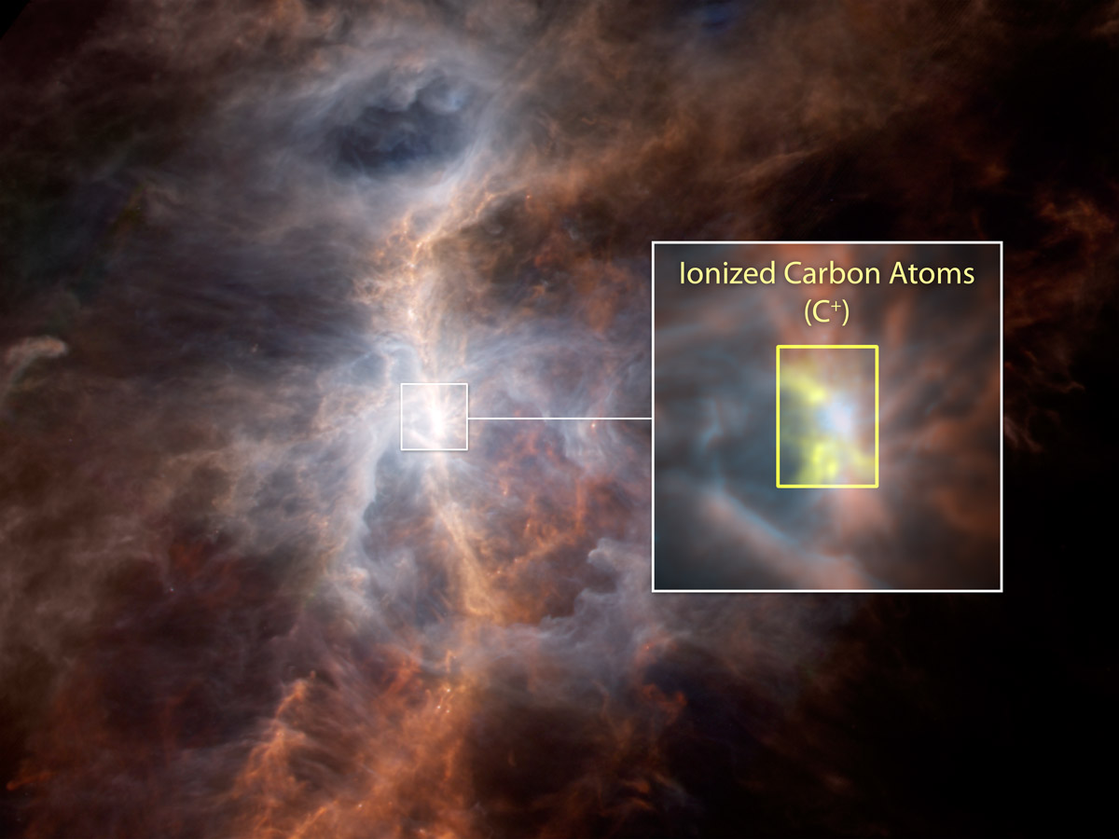

In other words, the matter that makes up our bodies originates from the stars which in the past heated up to the point where they exploded. The atomic nuclei fused in different ways and created the oxygen that we breathe, the hydrogen in our muscles, the calcium in our bones, and the iron in our blood. We are all made out of “star dust,” which means that we share this ancient bond with one another, other living things, and the very fabric of Space. It’s recycled in time, passing through all phases of the biogeochemical cycle but unchanged in its source. So on a subatomic level, we are immortal, and the particles that we consist of will always be present in the Universe in one shape or another. Quite a fundamental piece of information, don’t you think? But there is more – as always, the physical side is just the tip of the iceberg.

2. Emotional and intellectual level:

Inside our mind, we all live in a unique world, constructed by our notions and perception about ourselves and the environment around us. In that sense, every person lives in a different universe, which is singular and distinguished from the one that belongs to someone else’s mind due to different points of view at the moment of observation, different conditions that the person is in, different mood, different preferences and so on and so on. But that doesn’t mean that these states of existence aren’t interconnected. Quite the opposite – we interact with one another in every moment of our lives. Whether it’ll be a billboard or pop-up that annoyed us with its pointless message, a picture that made us laugh, a random stranger who was rude to us or smiled at us for no apparent reason, the absence of a loved one or their warm presence, the sounds of our favorite music, the ambiance of nature or the background noise of the city - every instant is filled with a continuous exchange between our inner thoughts and emotions, and those of others around the world. Every action or inaction we choose creates a wave of consequences that extends way beyond what we can observe and determines the future of everyone affected by it, including ourselves and even people we don’t know personally. So our behavior has a direct influence over the emotions and thought processes of others. Again a vital piece of information to contemplate in order to understand better and honor our complex connection. In light of all that, one can only make the logical conclusion that our deeds need to be well thought out and considerate of the effects they will have on ourselves and everyone else who might be affected.

So if you aim to be happy, then your actions need to reflect that and be directed towards achieving not only individual happiness and prosperity but also that of everyone around you and, as an extension – society as a whole. It probably sounds like a lot of work and a heavy burden, but in reality, it could be brought down to what people call “being a good person” – representing a source of positive energy and thinking patterns, acting in every situation that would make you happy and presents an opportunity for self-improvement and evolution, being caring, understanding, humane and loving. Attract positive people and distance yourself from those who try to sow discord and refuse to act for the betterment of themselves or others around them. Respond to kindness with the same and always try to turn around negative situations through temperance, logic, and will to solve problems, thus creating a favorable environment for growth, collaboration, friendship, respect, and trust to develop and flourish.

And vice versa – if you are unhappy with the situation and getting angry at everything around you but do not act to make it better or even worse – if you’re actively taking steps to provoke its deterioration, then there is no need to wonder why you are in that state. You are the one holding the key towards the resolution but refuse to come out of the vicious cycle and, in the process, drag everyone around you down with your inaction, wrongdoing, or inability to compromise, change and adapt.

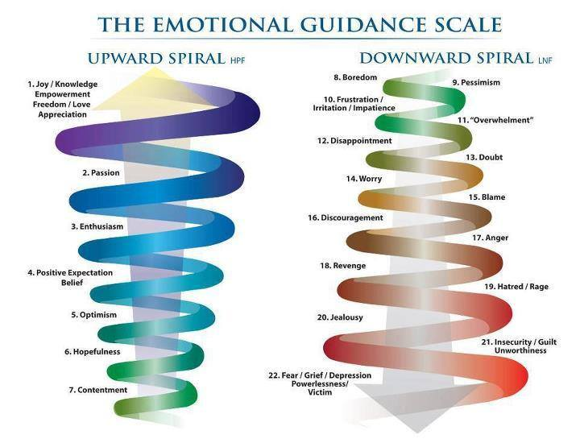

3. Energy and spiritual level:

Just like matter, energy never dies or disappears. It just changes its form and function in the Universe. Energy could be found in every piece of organized оr inanimate matter, constantly shifting into one of its forms – Potential, Kinetic, Mechanical, Thermal, Nuclear, Chemical, Gravitational, Ionization, Electromagnetic (Radiant), or Sonic, depending on the prerequisites for its transformation and the following result. From a practical standpoint, no process in the Universe could happen without some form of energy exchange. In order to perceive its omnipresence and see how everything is moved by it, we only need to look outside – the clouds with peculiar forms slowly moved by the cold or warm wind, leaves falling to the ground, attracted by gravity, lamps lighting the alleyways with electricity surging through them, people moving around with a snack or drink in hand, the city built by those people, and the Sun – generously giving its light to the Moon and half of the planet which turns and circles around it. Energy shines and flows through all the world, changing its form and purpose with every interaction. Humans realized its all-encompassing nature thousands of years ago, giving it divine characteristics – The Divine spark, a part of God that is everywhere, both outside and inside us, allowing us to change the world through our own will and actions. It’s not a coincidence that the Bible and many other manuscripts speaking about the essence of God start with 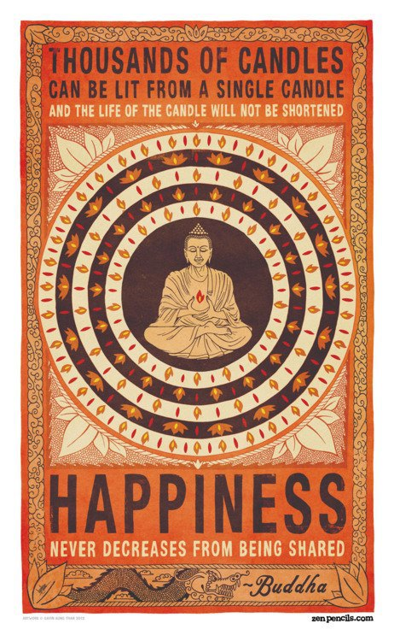an expression of this divine will – “In the beginning was the Word, and the Word was with God, and the Word was God. And God said, “Let there be light,” and there was light.” Energy is this sacred link between our inner world of ideas and the physical reality. We can change not only its purpose but also its charge. As strange as it sounds, we are living biological batteries - constantly storing, converting, and releasing energy. You have no doubt noticed that there are people who just by walking in the room have this gleaming radiance of positivity almost like they are shining, those who make you feel at peace with their warm presence, and also those who distort your comfort, put you off with a negative vibe, almost like draining your life force. This is communication and connection on a non-verbal energy level that works in sync with the physical, mental, or emotional to create the constant exchange we call existence. But we are not passive observers of these events. With proper education, training, and understanding, there is a way to control our energy flow. By imprinting our will and intentions onto our actions, we can give it a positive or negative undertone and create waves of similarly charged energy into the world and lives of others, influencing them directly or indirectly.

So through this text and everything I do in my existence and even after that, with my building blocks serving another purpose, I become an inevitable part of your life and you – to mine. The same applies to everyone and everything else in our life. As the last piece of the puzzle, that is our complex relation, falls in place, it becomes more evident that we need to change the way of life in our society towards a conscious reinforcement of that bond on all three levels. The proposition that I have is to achieve this through evolution in the way we approach and perceive other people and the whole world, not as objects outside us but as extensions of ourselves. A change in how we distribute the planetary resources reflecting this point of view through gradual technological advances and a purposeful rearrangement in some of the most influential aspects of our lives to ease and help implement it.

At the moment, there are many artificial hindrances that delay us or flat out stop some of us from growing above the primary needs for food, water, shelter, breathable air, and physiological necessities, which are on the first level of Maslow’s hierarchy of human needs. I will direct your 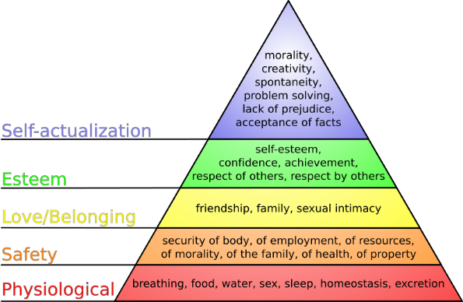attention towards each and every one I’ve noticed so far and, as promised – provide a critical reflection and a possible solution. The proposed changes will undoubtedly have a domino effect on all of our lives and hopefully - make existence a more wholesome experience. Once we overcome those obstacles, we’ll be able to reach a higher plane of existence and, as a species, will be ready to face even greater challenges together.

It’s now time for the practical side of everything I mentioned so far.

II. Education

I’m starting precisely with this subject because the educational process and the years in our life during which it is currently set to happen are the most important in forming our character, worldview, and finding our place in society. Some would argue that the period from birth until the 7th year of the child is even more fundamental, and I agree to an extent. I’m not going to look into it in detail since it’s a personal stage of establishing the relationship between parents and children. Also, the change in all the other areas of life and the implemented technological advances will make it much easier for a child to be taken care of, grow up healthy, and be taught to be brave, creative, and solve problems in cooperation with others instead of hating, fearing or being dismissive towards them.

So let’s take a closer look at the educational system in most schools today. As diverse and inclusive as it presents itself to be, from my experience, the learning process is universal for every student from beginning to end. All the people are subjected to the same pattern of activities and studies regardless of their individual qualities and interests. This happens even in specialized schools and classes, which puzzles me, to say the least. By going through the same motions as others, sometimes for more than 17 years of our life in total, the thinking process is unified and channeled in a specific direction, molded in a certain pattern making us live our life around the school schedule, which no doubt makes it easier to accept a similar work schedule after that. Any ideas that deviate from or conflict with the given and established facts and theories are not encouraged to be researched or explored but, to put it mildly, looked at with distrust and hubris. At the end of this slow process, most people have lost most of their individuality and uniqueness and are feeling more confused about what they want to do, which is definitely not the point of learning. Apart from that, the educational system relies mainly on mechanical memorization and reiteration of large amounts of information to cover more material in less time and take the coming exams successfully. But then most of it soon fades into obscurity from the memory since it has to be replaced with the next batch of info that must be memorized for the next exam in the curriculum. What this accomplishes is that it makes 99% of the process meaningless and useless because most of the knowledge that the educational system so proudly presents us with figuratively goes out the window. Oh, and let’s not forget that the students go through this entire ordeal in fear and stressed by the fact that if they don’t do well in school and they don’t get the required grades, then they will not keep up with the other students, won’t get the needed scholarship and be accepted in a school that provides quality education, and won’t find a profitable job (unless their parents are wealthy and successful, of course, in which case they could skip the entire process). And these practices continue 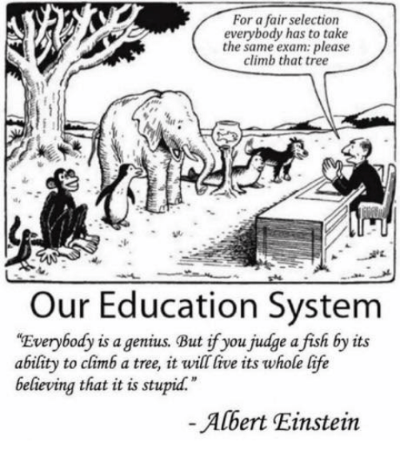with full strength in the so-called “higher education” – University or College, creating a whole society of nervous and psychologically overburdened people looking to express themselves through the “Holy Grail” of egoism, vanity, false sense of security and accomplishment – money. Don’t you think this is too much pressure and quite the redirection of a person’s energy from a young age when we are only starting to build up and develop ourselves? We need a clear mind to determine what drives and motivates us to move forward. Finding out what would give us the most pleasure and satisfaction to explore and devote our lives to should be the goal of this entire process, at least in my humble opinion.

To overcome these issues and move closer to the society I mentioned earlier, I propose starting with a purposeful change in the educational system and in the way we convey information to posterity.

A good first step towards that would be for the learning subject to be practically demonstrated, illustrated, explored, and tested by teachers and students on all levels of education. By doing this, we will achieve direct contact of the students with that subject while stimulating all types of memory we have (visual, auditory, haptic, olfactory, emotional, etc.), which creates a favorable environment for perceiving, learning, and eventually - re-creating and expanding on it in the future. It also allows primal creativity to occur naturally as an exercise, during an exam, or as independent activity later on. The knowledge received from the source will always be the most accurate, reliable, and up-to-date with the latest discoveries, technology, and practices in that area. Most importantly, immediate contact with the practical side, when done thoroughly and comprehensively, leads to the fundamental realization of how much this matter piques our interest, excites us, and sparks a desire to continue to explore and create in this direction. Reading literature and doing research should be done in parallel, aiming to complement and complete the practical knowledge and not substitute it. I’ll give a couple of random examples to illustrate what I mean: Languages to be practiced through student exchange programs and excursions; the class attending concerts of different musical genres and using musical knowledge to sing or play musical instruments; going to various sports games and speaking with the professional players and trainers, as well as practicing those sports; visiting biology, physics and chemical labs or observatories (with all safety precautions taken of course) and performing simple experiments and research; studying complex geographical maps and going to the regions and landmarks, which are being mentioned; getting a more practical and in-depth knowledge in the IT sphere, computer technology and sciences (It is all around us nowadays, I believe it will be beneficial); studying the day-to-day implementations of mathematical calculations, equations, algorithms, theorems etc.; achieving deep discussions and writing thematic texts within the topics of philosophy and literature; visiting museums of history and art as well as significant cultural heritage sites and analyzing their meaning to us; practicing different types of applied arts. And so, gradually, learning becomes much more exciting and stimulates the imagination and interest of the student. As you’ll see in the upcoming chapters, all of the above and much more will be a part of the overall social structure in terms of organization, resources, transport, and teaching staff. Of course, those practices exist within our current system as well, but they are often underfunded, too expensive, or eclipsed by forcing attention on the overwhelming amount of reading material and writing homework which is much less exciting and often is counterproductive, dissuading people from continuing in a field instead of helping them. This is absurd since the need to study the matter further, conducting research and exercises comes naturally to those who would like to excel in a particular field, but how are we supposed to know if we truly want that unless we experience and feel firsthand what it means to practice that subject?

The second idea I’m offering is for a revision in the way people progress within the educational system. At the beginning of this process, just as it is today, everyone will study the fundamentals of all the subjects since this is of paramount importance for the common knowledge base and individual development. This will continue until the student shows an affinity toward a specific discipline. After it becomes evident that the person has a greater interest and starts to manifest some basic creativity and problem-solving skills in that area, the educational process will change and become centered around the subject of choice, giving more emphasis to it and helping the student connect and share experiences with like-minded individuals. Of course, this will not stop anyone from studying other subjects if they desire to do so. There will be no penalty for leaving a class early or not attending at all – people will be able to come and go at their convenience. After all, education should not be a prison but a site for conscious learning and self-development. We need to be mindful that every person learns at a different pace, and their needs are diverse. The idea here is to allow the personality to exhibit its unique inner talents and, through suitable education, practice, and further clarification, to develop and achieve the peak form of that individual. This will also alleviate some of the pressure caused by relatives and peers to follow the path to what, in their opinion, is “the best specialty”. These people usually don’t know better than ourselves what drives us, and this conflict of interest could lead to some very undesirable outcomes. By placing the focus on that which is innately inside us, then gradually, through our actions and choices, we become more aware of what we enjoy doing with our time and in which direction we’ll feel the drive to create and solve problems. This will contribute immeasurably towards the self-realization and happiness of the individual and, as a consequence – the entire society.

The transition between the levels of education and classes will happen based on the student’s understanding of the subject matter and their practical skills instead of just testing their ability to repeat by heart the information they read in books or heard in lectures. In the proposed system, the exams will be conducted in two stages – theoretical (in the form of a dialogue between teacher and student) and practical (where the student will demonstrate and apply the accumulated knowledge and skills to create or solve a problem in that area). Through the dialogue, the educator will be able to determine how much of an understanding the student achieved in that particular matter, which area attracts them the most, and, of course, if they have acquired the necessary knowledge and experience to continue onwards with the educational process. The conversation will be in freestyle, in a tone of mutual respect, thematic to the examined material, and will precede and supervene the practical stage. This will create a unique experience for everyone participating in every exam. For example, it starts with a general conversation about the subject, discussing what excites and inspires the student in that field, and then gradually leading the dialogue towards that specific issue to the point when the examinee needs to demonstrate what they’re capable of. After that happens, there will be a verbal follow-up where the practical skills of the student will be discussed – mistakes that were made and how to rectify them as well as the strong sides and ways to further improve upon them. Such an exam will present a clear picture of the person’s skill set, interests, and mastery over the subject of education.

And so people will learn until they have a complete vision of that sphere of knowledge and are ready for independent creativity. As you can see, there are no age restrictions to the process since everyone learns at an individual tempo and will start and finish at a different moment in their life. All education will be free of charge or any monetary obligations, just like everything else in the system. The question about who the teachers will be and how we’ll achieve that will be answered in some of the following chapters – that is the most beautiful part of this project.

The last idea involves adding a new subject to the mandatory knowledge base of all students. It is to be studied with all others in the early stage of education since it’s fundamental for the existence of the society I’m proposing. No need to frown, the matter is fascinating. It will help us understand each other better than ever, to realize what are the emotions, feelings, and thoughts guiding our minds and those around us, to turn the pressure of trying to hide our true selves to be accepted into the purity, freedom, and calmness that come with simply being who we are. I am talking about emotional culture and ways to best relay information – studying cognitive, emotional, and intellectual empathy, both verbal and non-verbal ways of communication (body language, tone of voice, facial microexpressions), what they mean about the person who uses them and their surrounding environment. The practical way to teach that would be to have the classmates take turns to observe one another’s posture, the way they walk, the tone of their voice, and the different grimaces and mannerisms they use while trying to conclude how this person is feeling, what are they thinking, what is their general mood and how their surroundings affect them. After that, the teacher will make a scientific summary of what was learned and expand on it. While advancing in this subject and deepening their knowledge, the students will be able to read with precision the non-verbal signs that they send and receive from other people and also to metaphorically look at the world through another’s eyes – our bodies will interpret our true intentions, our words and gaze will be windows to our soul instead of a wall that separates us from one another. Having emotional culture will help a lot in realizing the primary fact that we are connected, and we form the social environment together, which directly affects all people’s lives. It brings our focus on the responsibility to keep honest and healthy relationships and a way of life, which in turn will raise the level of understanding, tolerance, and collaboration. It will also help us distinguish when we aren’t welcome and we need to distance ourselves or give more personal space to that individual. There is no need to limit the subject matter to only human interactions. Students could also explore the most effective ways to communicate with animals if they are interested or dive into the fundamental laws of attraction and visualization to get closer to their goals and self-realization. I hope that it would be interesting and useful for everybody to learn how to recognize these signs and understand the emotions behind the actions which so often elude us in our day-to-day interactions and are the basis for unnecessary disputes, misunderstandings, and distrust.

So let’s summarize – more practically oriented education in order to attain more profound, lasting, and applicable knowledge and higher professional qualities; progress with a focus on the individual perception and interests for realization, which will achieve freedom of creativity, refining one’s talents and being closer to our inner nature; adding emotional culture as a necessary subject to achieve better communication, empathy, and understanding on a global scale. A good start to the change, don’t you think? And for those of you who would say this is unrealistic and utopian, I would point toward the educational system in Finland, which uses similar methods and has provided great results for many years. As always – don’t just trust my words - question and check the information for yourselves.

III. Ethics and behavioral norms

Throughout our history, people have given countless lives to form and preserve the basic principles of acceptable behavior and moral integrity necessary for our survival as a species and to have a harmonious coexistence with the rest of society and the surrounding world. These norms work to an extent in our times as well – somehow, we manage to live together. This shows that our moral compass works well in the right environment, and our perception of what’s right and wrong is well in place. The fact that some of us decide to ignore them and consciously sow chaos and disruption is another matter entirely. With every passing era and fundamental discovery, we need to take a symbolic step back so we can observe and readjust our values in light of the new situation. After all, we humans are famous for our adaptive nature. I believe that such a time has come, and we must ask ourselves if we treat other people and nature the best way we can, if we use and distribute resources adequately, and if we are applying our newfound technology and capabilities effectively. I will talk about resource management in the later chapters, but here, I would like to turn your attention towards a possibility we have and must realize at all costs – to recognize and acknowledge both our multilayered link to one other and the divine power in every one of us to create, change our surrounding environment and influence living beings through it. We need to accept this as present in people of every race, religion, sexual orientation, culture, ethnos, and age and provide the means to use that spark of creativity with respect to our connection for the progress and happiness of all, expressing love and gratitude along with our inner world. I have hope that by following this way, the idea that humans are architects, creators, and even gods of their own lives, which partly provoked the scientific and spiritual revolution of the Renaissance and Enlightenment period, will be further developed and elevated to its highest point. We need to bring forward the role of every individual in presenting educated new ideas and perspectives, working towards discoveries, honoring both ourselves and everyone else as bearers of this unique gift by striving to constantly evolve and through rational thoughts and actions surpass the material and mental borders that deceivingly divide us.

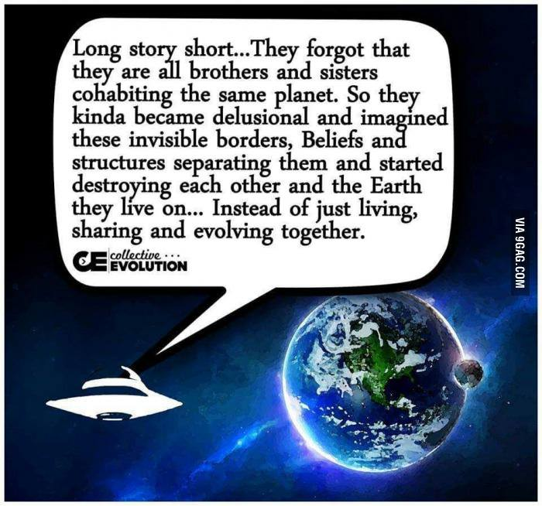 Some would say that this is very difficult to achieve on such a global scale since it requires reshaping the mentality, self-consciousness, and behavior of every person on the planet. It is a proven fact that the main driving force that forms our values and actions is how the societal structure functions. I am confident that the gradual change in the social environment, the standard of living, proper education, leading by example, and putting in the effort to make this way of life work, will inevitably lead to a gradual change in our perspective. We can start to evolve and achieve a higher level of existence. Once we move on from the day-to-day worries of providing basic needs to survive, we’ll have room to pursue higher goals and challenges. I can’t say it any clearer than this – if we give ourselves the opportunity and the right conditions to live together and honor our connection, then we will have a much more peaceful, calm, and pleasant world.

Let’s continue exploring more of the prerequisites and changes needed for this new age to flourish.

IV. Religion

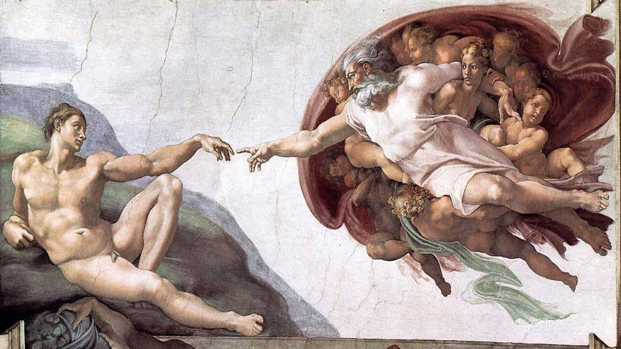

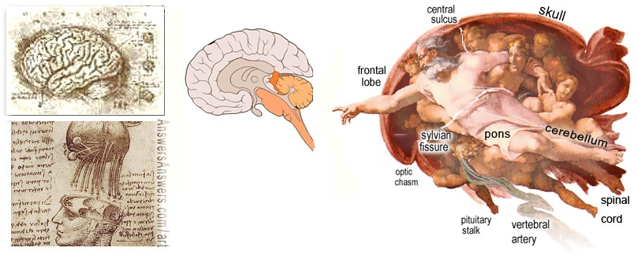

Throughout my humble journey in this life, I have witnessed two main incarnations of the phenomenon we call religion – individual (based on one’s personal experiences and understanding) and traditional or mass (derived from ancient texts, words of people deemed to be holy, as well as customs). Both of them are born out of our inner sense telling us that we are only a part of a much larger picture, that we have within us a tiny spark of forces that immeasurably exceed our capabilities and reach - forces that created the Universe as we know it and influence the cycle of life and death in a subtle, almost invisible to us way, fulfilling our need to see a grander plan and order. Some of us believe in the force of Nature and deify it as the giver and taker of life, calling it by personifying names like “Mother Nature” and following its unwritten laws as they have been for millennia. Others believe that celestial bodies and their movements can predict or provoke changes in our lives and the state of the Earth. For some, gods are beings with far greater power, wisdom, and understanding, and the Universe is just an exercise of their creative abilities. Others place the limitless knowledge of the world and divine power to face the endless challenges of existence not outside but within each one of us. We have the biological energy source, presence of mind, and moral compass that help us navigate through life, and between what to do and what to avoid, we only need to know how to wake the divine spark that’s already inside us.

   Interestingly enough, all of this is true in one way or another. Since every person looks at the world and evaluates it subjectively, knowingly or not, we create our own religion, built upon our experiences, understanding, and level of spirituality. The beauty in all these options is that there is no right or wrong, no religion that is “more correct,” “superior,” or above the others since they are all just parts of the bigger picture. As an example of the colorful range of personal beliefs, I will add my own since I’m not a believer in any of the mainstream religions in the form they are being presented at the moment. I believe in energy. Yes, energy – something that actually has its existence proven. As I mentioned earlier, energy is omnipresent, both within and without, it has been so since our creation and will be so in the future. It presents the invisible thread that connects us all, and as the First law of Thermodynamics states, it cannot be created or destroyed but instead changes form and properties. People have the fantastic gift of purposefully reshaping it when they are mindful of their intent, focus, and actions. If we manage to unveil, understand, and responsibly use all the types of energy and the forces that they govern, we will have the potential to turn the entire Universe (along with everything else that is yet to be discovered) into our playfield and become the deities that we now bow before in awe. Looking at our current state, it wouldn’t be that outlandish to say that if we find a solution to our serious energy crisis and get to a point where it is renewable, freely accessible and propelling our factories and vehicles, it will lead to an ecological and technological uplift of our society.

  My personal view is that people should form their own spiritual values based on their experiences while seeking enlightenment and being presented with the options of different religions, rather than trying to live their lives by the laws within antiquated texts and books or, even worse – forcefully being indoctrinated into blind faith without considering any alternatives. Any teaching that claims to be a religion should not preach purposefully harming other beings in any way since that is fanatical and doesn’t lead to any positive outcomes, as our history has proven time and time again.

   Let’s shift our attention to global religions. Like everything else in this world, they can become a powerful means for achieving unity or division among people, depending on the focus and purpose of their message. In the beginning, people have decided to combine their common viewpoints, fears, inner wishes, and hopes about the essence of the Divine by composing stories that, in an epic fashion, tell of the deeds that gods perform to enact their will on Earth as well as the arguments between them. Looking a bit more in-depth at today’s religions, it becomes evident that they are written predominantly by adopting ideas from more ancient religions (which oddly enough are proclaimed to be pagan and even satanic afterward) and in a metaphorical way reflect on the different ideas, issues and spiritual discussions which wandered in our minds since our genesis as a thinking species (like our beginning, meaning and end of life, how to be honorable and just or to find inner peace, what should be the punishment for a crime and how to achieve a balance in life, etc., etc.). Over time with the forming of different religious teachings with overwhelming amounts of followers worldwide and realizing the tremendous power that the priests, shamans, and spiritualists can have over others, the goals of those religions started to change. The priesthood hierarchy has always been one of society’s most influential classes, holding second place only to the ruling elite. In most cases, the two groups live in symbiosis - each one consolidates and affirms the significance and necessity of the other one and indirectly – its own authority, of course. It makes sense that if a person sincerely and wholeheartedly believes in something or someone, then they can be easily manipulated and controlled through interpretation of the Divine will in a way that suits the interpreter. In their pursuit to achieve absolute dominance, the clergy called for special meetings during which the highest ranking members revised the holy texts in a way that corresponds with the interests of the ruling class and thus shaped a religion that preaches blind faith and obedience towards an invisible figure of authority which can subconsciously be juxtaposed with the image of those in power. During the Middle Ages, the ruler was proclaimed to be the earthly manifestation of the divine will, and the belief in God was to be unconditional because asking questions meant you were a witch, heretic, or non-believer, therefore, subject to severe punishment. And these techniques are used to this day to manipulate the masses and justify actions that would otherwise be unthinkable to undertake. Do you think it’s a coincidence that in every public speech, the people in power use the phrase “God bless our country” and repeat it like a mantra? They are trying to invoke the image of the Godly figure with their appearance. In many countries, the young are still being taught not to question what they learn and receive as information (be it through religion or otherwise) because it’s blasphemy or because they undermine authority. This approach creates unhealthy stagnation and a lack of progress.

   With the thousands of years that passed from their genesis, most of the original ideas of the religions has been distorted to the point of becoming unrecognizable. We are now witnessing or being part of unbelievable phenomenа, such as:

   - Imposing a belief through violence, harming others, and even waging war in the name of religion. This is the most absurd thing to me. If a particular faith needs to be spread through violence and not accepted willingly and freely by the people, then it is no faith at all, just a self-preservation instinct.

   - Destruction of works of art and architecture due to differences in belief systems. Such actions cause disrespect and distrust between people of different religions and bring God’s will down to petty vandalism.

   - Higher members of clergy surrounding themselves and parading with immeasurable riches and, simultaneously, asking for money from the believers and congregations. The moment greed takes over and what was supposed to be a humble and spiritual gathering turns into a fundraiser, show, and demonstration of superiority above other people, is the moment it becomes clear that the whole situation is a lie and these so called “holy people” don’t care at all about others or the state of our soul.

   - Sexual perversions within the clergy. Yes, we are all humans. I recognize we have our urges, but for people representing faith and religion to engage in such practices as regularly visiting prostitutes or “converting” new members into homosexualism and even pedophilia through falsely interpreting holy texts to justify these actions, is disgusting, corrupts the faithful, undermines the foundations of religion from within and puts in question the very need for supporting the existence of an entire hierarchy of priesthood.

   - Redirecting people’s attention away from this life and into the Afterlife. There is no need to worry about going to Heaven or Hell because this is just another technique of shifting your focus, energy, and goals away from resolving the real issues our society is currently facing towards something that is inherently created with the intent to keep us in control through promises of undefined bliss or fear of very defined punishment – the greatest story ever told, as people call it. Because Heaven and Hell are states of perception of reality, nothing more or less than that. Depending on how we see the world around us and what we do in our life, there is only one Heaven or Hell – the one we are currently in. I believe in our existence even after we die – I already mentioned that our matter, will, and energy continues to move, shift and act perpetually. I am open to the possibility of higher planes of existence and understanding. But these silly cardboard cutouts of “Good” and “Bad” are nothing more than a tale to keep us obedient to the status quo, our actions dumbed down and simplified so we don’t think outside those boundaries towards a higher purpose or change in our society.

  All of that, paired with the religious hatred, makes me feel amazed by the ignorance of so many people about a fact that seems to be eluding them but is quite apparent when you do the research. It’s fundamental for an eventual change and evolution in the state of religion. That is, all of the religious teachings and beliefs in the world are based around and interpreting the same story, told through the viewpoint of different people. In the era of information, it is high time we realize that we all believe in parts of the same bigger picture. The differences in traditions, customs, ways of telling the story, architecture, and different interpretations are more cultural than religious, don’t you think? The fact that the story is written in another language, the temples look different, and the names of the prophets are popular in those lands doesn’t mean that the essence of the teachings has changed. In one of his shows, the popular stand-up comedian Eddie Griffin says: “People around me argue all the time about who is the real prophet of the Lord. I say: Who cares about who the prophet is? Did you get the message??? And the message of every religion is: “Do unto others as you would have them do unto you.” Science has proven that to be a fact – for every action, there is an equal and opposite reaction.” In other words, the essence of all religious teachings around the world is similar. Please think about this for a moment. This information makes the whole mess with preaching the only “real” and “right” religion unnecessary and opens the doors to a more harmonious society – united in faith but diverse in customs, culture, and ways to interpret the word of God.

   If you still feel skeptical about what I’m saying, I would recommend watching a very clear exposition on the subject, rich with evidence and examples pointing towards the similarity in different teachings around the world. It’s a movie called Zeitgeist (meaning the spirit of the age/times), which is freely distributed on YouTube. It’s more than 2 hours long, and there are three movies in this series, but just for information on the subject, you can watch the first part of the first movie, named “The greatest story ever told.” It helped me realize and reject many illusions and artificial divisions that spread their influence nowadays.

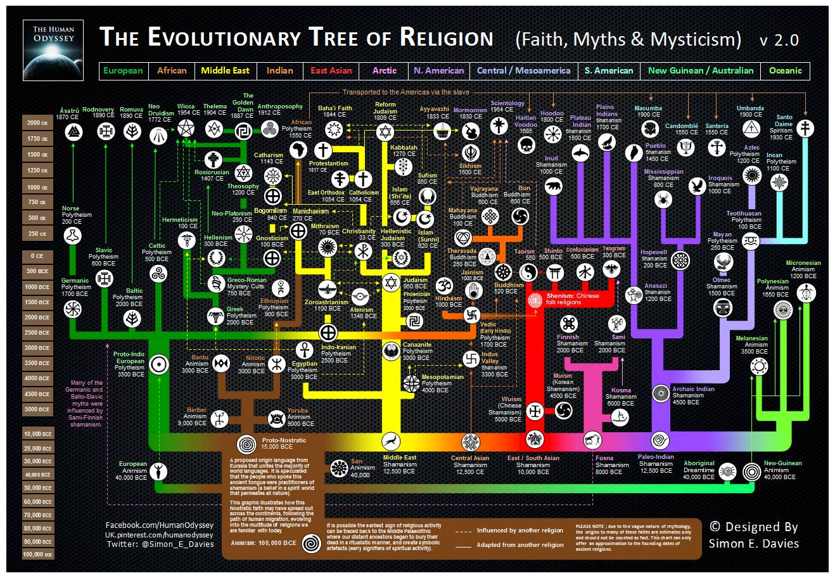

   My proposition for the evolution and change of religion, first and foremost, is for global recognition and acceptance of the fact that all faiths and beliefs throughout the world are parts of the same phenomenon, equally significant and valued for their uniqueness and contribution to our culture and spiritual growth as species, revealing different fragments of the Divine mystery. This is obvious to every person who is perceptive, thinking rationally, and who’s made an effort to research and acquire knowledge on the subject. Also, clergy members and monks should be people who feel a calling and have the will to devote their life toward reaching spiritual enlightenment, inner peace, and harmony with the material and ethereal world. As with every other, this creative activity will be done voluntarily without the need to artificially maintain a whole religious hierarchy that assumes people of higher rank are closer to the Divine than others. Again, history has proven that to be incorrect, with many so-called “holy men” preaching the word of God, but practicing the very opposite. In any case, we don’t need elderly folks in robes or beautiful young people in suits looking at us arrogantly and telling us what to believe in. What we really need, is an example from those who are sincerely dedicated and devoted to achieving a higher understanding of their faith, practicing with bliss and happiness both in moments of struggle and in rest. As for our souls – I believe that every one of us can tend to our own temple of spiritual energy with a bit of inspiration from such enlightened individuals.

   I want to show you a glimpse of the world I envision and what our future could be if we choose and direct our lives towards it. Imagine a world where all the religious teachings coexist in harmony, accept and honor each other as fragments of the divine truth without giving an advantage to any one of them or any person practicing them. Imagine grand cathedrals and synagogues, mosques with towering minarets, beautiful Hindu temples that stretch for miles, monasteries high in the mountains, sacred sanctuaries of the old gods or the five elements of Nature – fire, water, air, earth and mind, astrological observatories and all kinds of other temples. Each with its sacred teachings, philosophies, and ritеs, worshipping both the human and godly power of creation equally, being unique but also recognizing that they are only a part of the phenomenon called religion. Because all of these wonders and variations are made by people who want to praise God in their own way, and that is enough proof that we have a part of the Divine within us - the means, will, and potential to create even greater wonders. Most of what I described in this paragraph is already happening to an extent in my city. This gives me comfort that what I’m talking about isn’t just a dream but a likely possibility if more people and places are inspired to be like that.

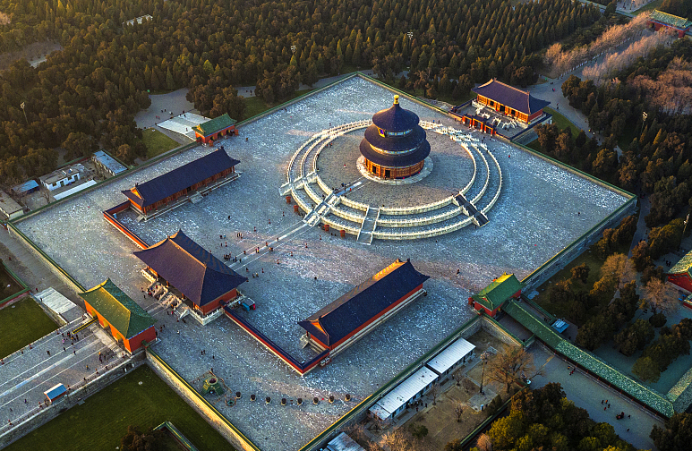



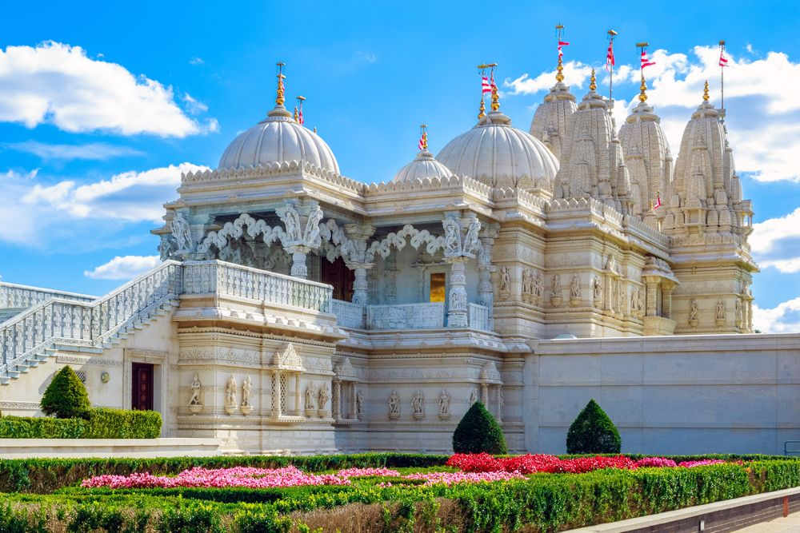



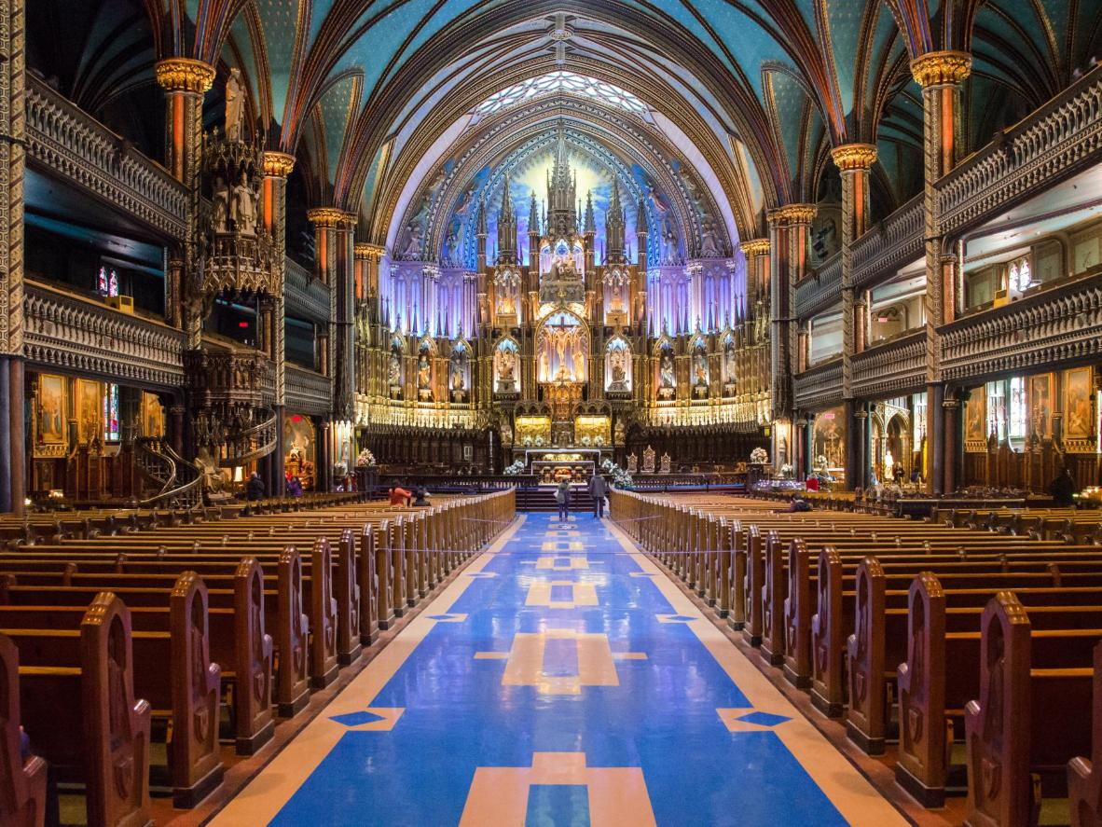

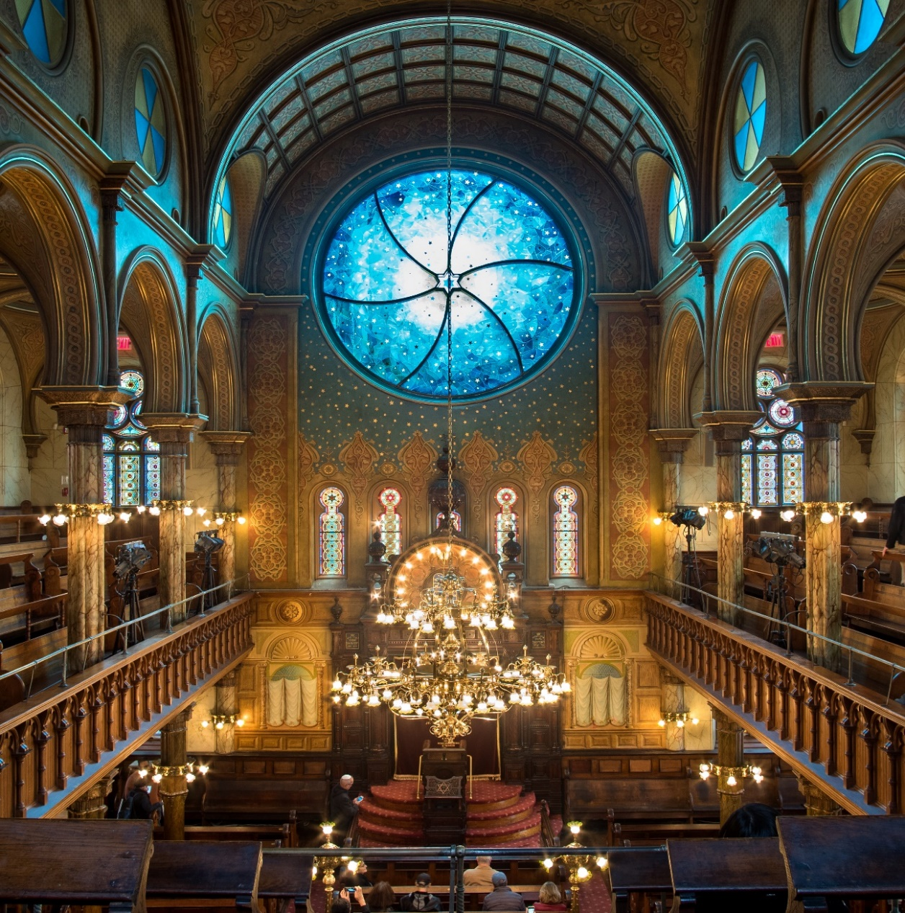

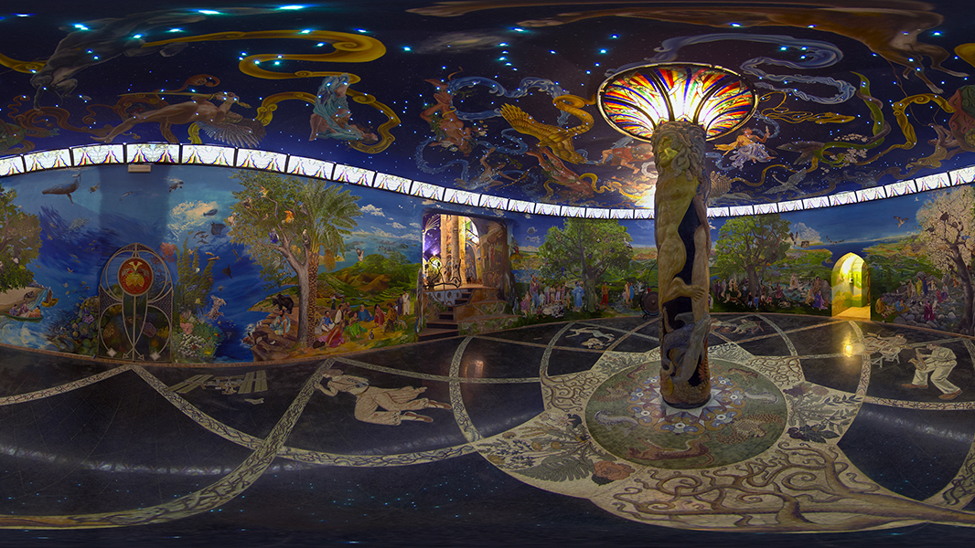

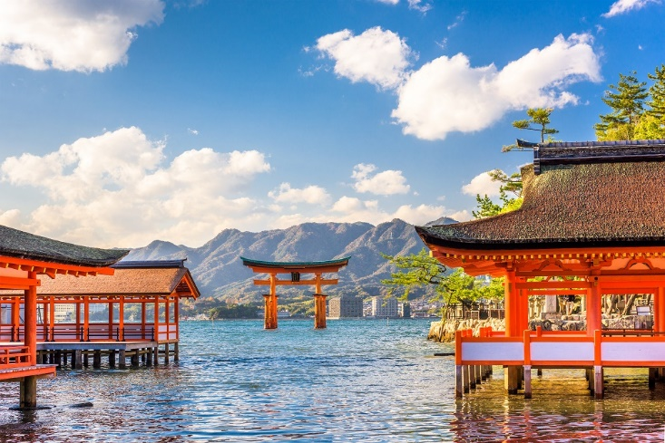

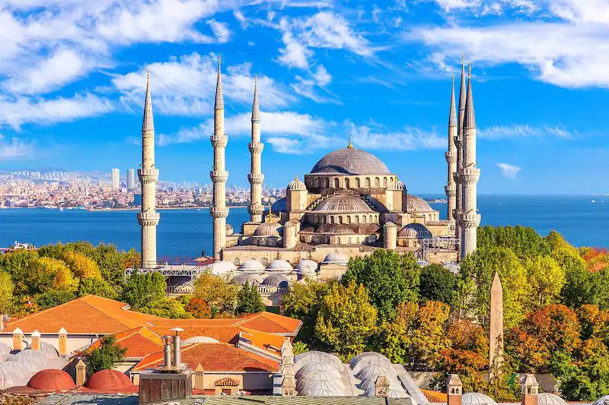

   As an end to this chapter, I’m going to talk about the image of the Devil. Yeah, I know – the text took a bizarre turn. But when we talk about religion, it would be unfair to look only at the light without acknowledging the existence of darkness. Of all its incarnations – the horned god of nature and fertility, the bringer of morning light (that’s the literal translation of the name Lucifer), angel of darkness, the destructive side of God or simply the embodiment of everything that’s rejected and unacceptable by society, my personal favorite is the symbolic representation of the Devil in the Tarot. This interpretation succeeds in very accurately depicting the real essence of evil in this world. In the Tarot deck, card number 15 (XV - The Devil) symbolizes resigning yourself to an undesirable situation, putting up with unhealthy stagnation and addiction, focusing the attention only on the material side of life and overindulging in it while neglecting our higher needs and the development of our soul, the unwillingness to open your eyes and mind to a different perspective, fear of the unknown and as consequence of all that – a feeling of desperation, hopelessness and fanatical negativism. In other words – the lack of will or motivation for someone to independently find a solution and exit a vicious cycle. The cards go one step further by presenting a possible way to move forward from such a problematic situation with the next card in the deck – The tower struck by lightning (XVI – The Tower). It represents the destruction of the Ego, caused by forces outside of our control that bring a fundamental and sudden change in life and point of view, a revelation of truth and release from all pretense. In a sense, that is what I’m trying to do through this text – to shake your notions and conceptions of our society and possibly – change your outlook in a peaceful way. If you like even one of the ideas I present and it finds its home in your heart and mind, then I’ve reached my goal.

   Here is the most straightforward religion you can live by – always strive to improve and overcome your inner demons while helping others and respecting their efforts to achieve the same.



V. Money

After all these thoughts on the ethereal, let’s not forget to take care of our bodies as well. But what should the societal system be to produce and distribute high-quality goods to all people effectively? Maybe we should stick with the model of the market economy that’s in use at the moment and has been for so long. Let’s take a closer look at it and determine if it’s worthy of governing our lives in the future.

Money as a concept is introduced into our society more than 3500 years ago in the ancient Babylonian empire. The first Lydian coins (from ancient Anatolia) are dated around 700 years BC - quite an old invention compared to the pace of technological growth and advancement in modern days. Wars have started and ended because of money. Like everything else, our invention caused both happiness and suffering, played a fundamental role in driving international trade, relations and progress forward for our species, getting us to the point we are now.

With our dynamic lifestyle, people are starting to see the monetary system as more of an obstacle and hindrance to our relations and goals rather than the force of progress it used to be. Money seems to be a source of many negative practices and patterns of behavior. I’ll mention some of those as we go further, but I’m sure you can already think of a few. A proverb even states that “Money is the root of all evil.” I don’t believe that to be the case since the concept of good and evil predates the existence of money and will probably outlive them. That being said, we cannot close our eyes to the reality we have created for ourselves. We live in a world where life has an assigned monetary value from birth to death, lowering our existence to a sum of completely irrelevant coins, paper, or numbers on a screen. Is money really equivalent to life? 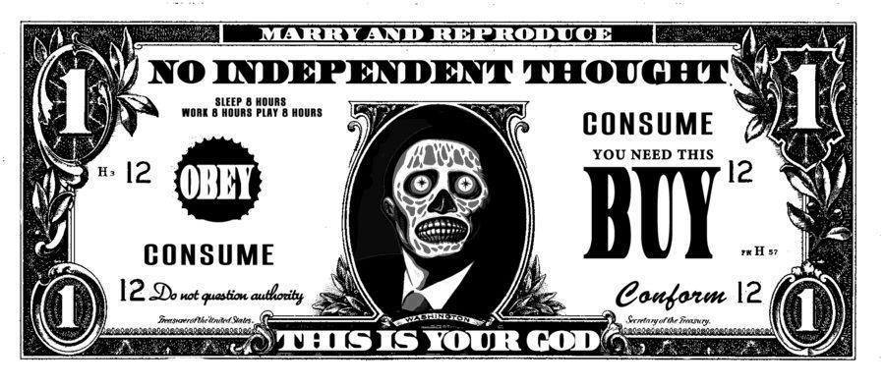

I hope the answer to this question came to you as quickly as it did to me – of course not! Money has only a fictitious value – the one we as a society agree to assign it. Before our times, during the 19th and early 20th centuries, this value was based upon the quantity of gold in a bank’s reserves, but the so-called “Gold standard” has long since become a part of history. As it stands, money has literally no real value and is being printed only out of necessity (fiat currency). But the banks don’t just create money. As privately held companies, they loan it to the government with interest and all its other characteristics. Yes, that’s real. The funds that the banks print, supposedly to support the needs of our economy, come with a built-in interest and, therefore – need to print more money. It seems that the bankers really played their cards well, making sure we are perpetually indebted to them. Since their creation during the 17th century, the central banks have controlled our countries’ politics and decision-making by financing specific individuals or parties, arming peacekeepers or rebels, and artificially causing inflation or deflation depending on their private goals. All of this is not only possible, but it’s happening every day and enabling a consolidation of wealth and influence like no other before. The so-called “ruling elite” or “the top” 1% of society owns more than 51% of the world’s wealth, making this group of people richer than all the remaining 99% of the world’s population put together. That doesn’t look to be very balanced, fair, or humane. In fact, it looks like a pyramid scheme that’s been enabled by the laws and governments throughout the world for far too long. Do you think these people use the immense resources at their disposal to survive and cover their basic needs? Maybe they use them to express themselves and their inner nature? Or perhaps they use their power for the prosperity and progress of humankind? Well, not really. When I look around, it starts to become painfully obvious that those same resources are used mainly to keep this scheme going through means of stagnation of the societal structure, spreading crippling fear, drunken haze, adding confusion about facts and events, unnecessary inconveniences and shortage of funds, completed with an almost uncontrollable desire to irrationally and illogically own more. As we can all see, the mainstream media is being financed to show the world above all else in a negative, vicious, debased, and unproductive way. In many countries, the arms industry is being funded more than the healthcare systems. Multinational corporations prey upon the indigent by exploiting their situation, offering laughably low wages while selling the product of their labor as luxurious at unreasonably high prices. The political parties are presenting an illusion of choice between different names, which are, in fact, being financed to serve the interests of the same private companies and to pass laws that facilitate their operations instead of helping the average citizens – a parody of real government. In this system, corruption and scare tactics impose their rule over free-thinking, ingenuity, and problem-solving. All of this is done with the ultimate goal of converting most people into obedient workers who willingly support the scheme as it is – providing those 51% of the world’s wealth to 1% of the population while the rest are left to sort the remaining 49% among themselves. It’s still hard for me to understand how this is an acceptable way of living to both parties and how it is viewed as anything different than slavery to an artificially created debt.

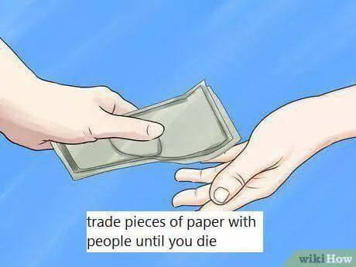 Let’s take a look at what’s happening with the other side of the coin, so to speak, while the “ruling class” orchestrates all of the above. Not a very pleasant sight, as you can imagine. We live our entire life according to a plan oriented towards procuring pieces of paper that lost their value long ago. From the education system, through the years of work, right up to the retirement age – the focus is on money, money, and again - money. Our existence goes by and around the study/work schedule. We are all obliged to either comply with it or perish. I believe people are intelligent enough to see that there is something wrong in this situation. Our own invention has turned into chains not only for our bodies and actions but also for our minds and thoughts, turning us into slaves of greed. People sell their homes and those of their parents for money, sell their dignity, their health, even their life, and those of others for money. Most crimes nowadays have a financial motive – theft and robbery, creation and distribution of illegal drugs, fraud, prostitution and running brothels, trafficking of guns and people, organized crime syndicates, corruption, etc. The list is long because people are ready to do anything to ensure their means to survive. And all that is happening while stores are filled with goods, pharmacies – with medicaments, anything we need is available. It can even be ordered online and delivered to our doorstep if required. Do you want food and drinks? No problem – it’s here but give the money first. Do you want treatment or a cure for a disease? The medicine and doctors are here but give the money first. Do you want to build a new house? The materials are here, the workers and machines are ready to help, but money first! Do you want to have clothes? They are here, but money first! Do you want to maintain a relationship with your partner? Do you want to take care of your family? Do you want to travel and see the beauty and diversity of this world? Do you want to live freely and make your dreams come true? All of these noble pursuits have to take second place to the grueling task of “finding means” to realize them, which have been close to us the whole time, but in this weird system, we cannot reach them unless we pay first or go to jail as a consequence of not doing so. This, of course, doesn’t apply to those who are wealthy enough to afford to be above this maze. For such people, none of the social norms, standards, and laws we accept and abide by seem to apply since they can control the outcome of every situation by paying a certain sum to achieve what they want. So, in summary, it turns out that if you have enough money, everything is possible for you, and if you don’t – it is not. Somehow, we have become completely dependent on these unnecessary pieces of paper. It doesn’t even matter which currency it is, since now we can easily change between them without an effort. With the use of digital transactions, cryptocurrency, and the genesis of hackers, it gets even more absurd – with the right tools and skills, whole bank accounts can appear, disappear or change their content at will. And in the meantime, the governments and banks, who have a tremendous concern for our well-being, of course, for some reason, decide not to print enough money for everyone, even though they are the only ones who legally have the right to do so. Because the truth is that if they do it, the whole system will lose its purpose and fall apart. The lack of resources is an illusion created to perpetuate this pathetic state of existence.

In this way of life, creative activities which should be practiced with joy and for the individual and greater good are instead turned into an inevitable faith and burden. Time and need pressure people into taking responsibilities that don’t fit well with their abilities and personalities or do not correspond with the peaks and drops in their productivity throughout the day. Instead of freely choosing our field of expression, we are forced to make do with the options available at the moment, that are well-financed and well-paid, or find a suitable environment away from our loved ones. After all this stress and strain just so we can have the coveted means and money we need, there may not be enough time or energy left for pursuing noble goals.

So I’m asking: Why is all this necessary? This way of life is humiliating and worthy of ridicule. There are many world-renowned comedians like George Carlin, who’ve managed to illustrate and capture in an amusing way how tragicomical is the state of society right now. For a minute, let’s try something. Imagine that, instead of having money, we are holding a single piece of paper with writing on it that says: “We are all humans, we are connected, we all have identical basic needs, and the presence or absence of money isn’t going to change that. We all deserve recognition, respect, and provision of these needs for the prosperity and harmonious coexistence of all. We have the technology to do so.” I hope you agree that it truly is so. The sooner we can shed our messed-up value system and admit this to ourselves, the sooner we’ll start working on a lasting way of covering those necessities for everyone so we can evolve and be free to pursue higher goals than our basic survival. Let’s redirect our energy towards bettering our quality of life by choosing a different path for our future. 

In some countries and even international entities, there are discussions and even attempts to implement what’s called “Universal basic income,” which is, in essence, for every person to receive money on a monthly basis to sustain themselves without the requirement to work for it. This initiative recognizes the issues I spoke about but ultimately doesn’t present a true alternative since it sustains the market economy as it is with a little bit more humanity in it. What I have in mind is a scientific way of effectively distributing goods where they are needed without the requirement of payment. Did I get your attention? It exists as a very enticing concept called “Resource-based economy.” It envisions a world where banks, pawn shops, taxes, and monetary debt are a thing of the past since they seem to only slow down processes that would occur naturally anyway.

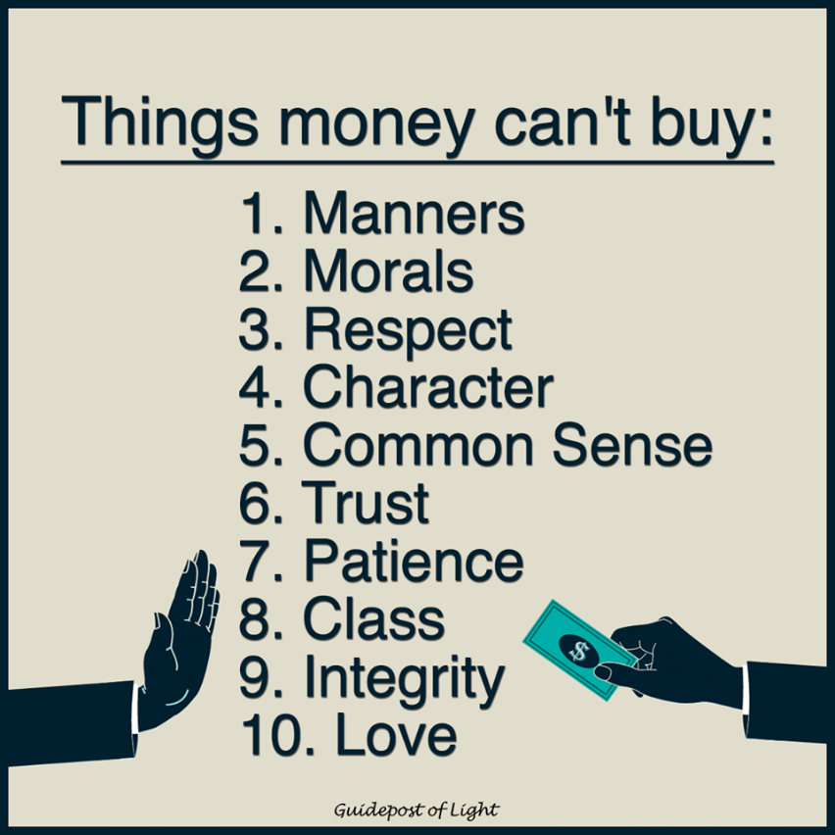

VI. Standard of living

So what exactly is a Resource-based economy? I’ll try and explain it in the most simplistic way I can. Please keep in mind that this isn’t my idea – it’s a product of years and years of research and development done by people (Jacque Fresco in particular) looking for a healthier alternative to the money-peddling scheme that is our society at the moment. Here is a reference to the official webpage of this project <https://www.thevenusproject.com/resource-based-economy/> because it’s always best to gain information straight from the source. It’s a system that proposes declaring all the world’s resources common heritage to all people instead of specific countries having control over them, which only creates a basis for unnecessary scarcity and conflict. After we accomplish that, we will conduct a series of surveys regularly to determine the amount, location, and state of those resources (yes, all of them), as well as where they are needed in order to be distributed in the most efficient way. If that sounds too grand in scope, keep in mind that most of the surveys are already happening even now on a local level, they just need to be compiled and sorted in a more extensive database that covers them on a global scale.

   Another point is to localize production by using the latest technological advances we have access to so we can create more food and goods of considerably higher quality that last longer and are efficiently distributed. This step will reduce the need to get new things constantly or for goods to travel halfway through the world before they get to you. People will have access to them at the distribution centers or so-called “libraries.” Imagine them like malls of the future where you can get anything you need without a price tag. The only condition would be to return the item when you no longer require it or if it needs repairs. That way, there will be no need to hoard stuff that you don’t use regularly so that it can be available to others in the meantime.

   The Resource-based economy enables using renewable energy sources by utilizing the landscape in a particular region to its fullest potential and implementing the newest advances in that field to maximize the energy output. The repetitive, mundane, and non-creative tasks will be performed by machines designed specifically for that purpose. This will make way for people to pursue their true interests, learn, evolve and create in the fields they choose to advance and develop further. It’s purely a scientific way of resource management that uses technology and a holistic approach toward ensuring abundance and prosperity for all people. There will be no politicians, monarchs, or clergymen who determine our way of life, instead of that – digital systems, machines, and scientists who only make informed decisions in the field of their expertise based on the information they acquire while accepting that their work can always be improved upon or proven wrong, which is the essence of research and development. Meanwhile, goods will be distributed regardless of personal opinions since they are proclaimed common heritage and vital to our survival. Systems will be implemented to minimize tampering with the normal functions and maintenance of crucial parts of the cities. People will be able to move freely without the need to cross borders. Means of transport will be diverse, and there will be options between driving a personal vehicle or using the faster (at that point) public transportation.

   It all probably sounds a bit too good to be true, but believe it or not – the blueprints for all that to be put in place already exist. I’ve seen them just by doing some extensive research on the subject. We only need to shift towards a different mindset that demands this to become the new standard of living while acting to achieve and preserve it. All the information is described in detail inside the webpage, as well as multiple books, online lectures, and movies. I’m sure a question is now forming in your mind.

VII. How do we get there?

Please keep in mind that everything I’m mentioning, as it’s always been with societal change, is a long process. It started in the dawn of humankind and will continue long after our own lives, so we cannot expect the results to appear with a snap of our fingers. Still, there are many initiatives we can undertake in the present to direct our development as a species towards that way of life:

   1. Technology, computers, and AI – Our goal is to create a world where most monotonous and repetitive tasks in production, assembly, construction, transport, services, resource management, city maintenance, etc., are performed by machines that are programmed in advance for this exact purpose. They don’t need a salary or days off but will have self-maintenance and reconstruction protocols which will require a constant energy source, materials that can be recycled, and complex programming so they can operate correctly and efficiently. All the processes that can be automated will be. If this sounds like a scene straight out of a science fiction story, just think that with the exponential development that we are achieving today in the field of technology, it is very much within our capability to create. For reference – only 130 years ago, during the times of French writer Jules Verne, concepts like flying to the Moon or exploring the deep ocean were considered precisely science fiction but are very much a reality at the moment.

   And so, what can we do today to make these multifunctional machines work? The various pieces of tech we’ve got right now aren’t flexible enough with calculations, software, and in a purely mechanical sense, to efficiently perform the responsibilities we plan on giving them in the future. So in that direction, we can invent more powerful, faster, and more compact computers which will be able to interpret the complex software programs required and outfit them with mechanical bodies suited for performing specific tasks with precision and swift reaction. Also, lots and lots of programming will be necessary for all of this to happen. The programmers will regularly consult and work closely with specialists who’ll be able to clarify the details and subtleties in the field they are creating in and will help shape the code in a way that will be as productive as possible. Every task will be broken down into a series of simple commands, completed with protocols for self-repair, fixing other machines, and reinstating working order, as well as protocols for preserving the safety of humans around them if needed. Strong anti-hacking, power surge, and EMP protection will be implemented to prevent or minimize any unwanted interference that would disrupt such a system. If programmed successfully, the machines will not require artificial intelligence (AI) since they’ll only be following the commands within their programming without the need to make decisions outside of it. You can breathe a sigh of relief and leave “The Matrix,” “The Terminator,” “Space Odyssey,” “Mass Effect,” etc. inside the wild imagination of their creators.

   Looking at the pace at which we develop and upgrade technology, we can safely say that within 3-4 decades, we can have the necessary machines with a flexible and durable physique and powerful computers, ensuring an optimal link between software and hardware (mind and body, if you will) which will lead to an effective, high-quality, long-term, and safe work-life cycle. All of those are initiatives we can start researching, realizing, and testing even today. In some parts of the world, people have not only invented but are also implementing such tech. Please search for information on 3D printing, quantum computing, assembly line robots, robot chefs, self-driving vehicles, the Henn Na hotel, hydroponic farming, and so many other wonders of the New Era which have a revolutionary significance and a testament to our creativity but are yet to become popular worldwide.

  2. Energy and energetics - While envisioning cities and whole societal structures being supported by electrically-driven machines and vehicles, we can’t help but ask ourselves what kind of energy sources will be required and able to output enough power to keep this system operational. Many scientists and even governments are working to overcome this issue, implementing renewable sources and making energy abundantly available to everyone, transcending the need to burn petrol for fuel. Some of them, most notably Serbian-American inventor and engineer Nikola Tesla, who devoted most of his life to solving this problem, had all of their work and research seized and classified for unknown reasons. On the other hand, we have companies, like the ironically called “Tesla” who are pioneering the field of electric cars and are giving us hope that most of the vehicles in the future will be eco-friendly, quieter, slicker, and will not require gasoline to move. There are concepts like smart energy and zero energy buildings, which offer a two-way transit of electricity from and to each building to maximize power consumption efficiency and feed excess back into the energy grid. In any case, we will require a long-term or, even better - a permanent solution to our current energy issue via the use of clean, reliable, and unlimited energy.

   So what sources can we use? There are as many solutions as there are regions in the world, because energy is everywhere, like I said in the beginning of this text. I’ll give you some examples of clean and renewable energy which is being used at the moment just to get your mind going in that direction:

Geothermal – Produced by the constant natural heat coming from the Earth’s core. A powerful energy source right beneath our feet.

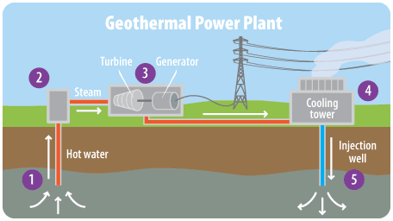

Hydro, tidal, and wind power – Forces used from ancient times for multiple purposes, quite strong in specific parts of the world, unlimited, clean, and waiting to be harnessed.

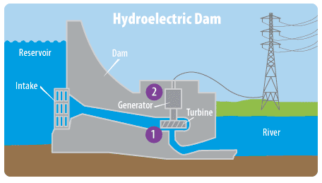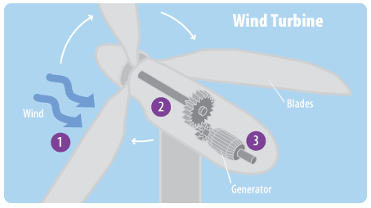

Solar – The Sun has been deified since the dawn of time as a source of energy, light, heat, and security for life on Earth. It is the most powerful thermonuclear reactor known to us, and we should use its gifts as much as possible. And that’s happening – solar panels are becoming more popular and less expensive over time, slowly replacing and chosen over other means of energy production. From remote farms in the fields, through hundreds of thousands of residential and industrial buildings in the cities, to the artificial satellites and orbital stations – all of them have found the use of solar power to be the most convenient and green energy source applicable. Just as an example of the creative genius we have, I’ll mention that there’s available technology for building solar roadways – durable to the traffic and outdoors conditions, transparent, and allowing the road itself to gather solar energy and distribute it to nearby buildings, instead of just passively being heated up by it.

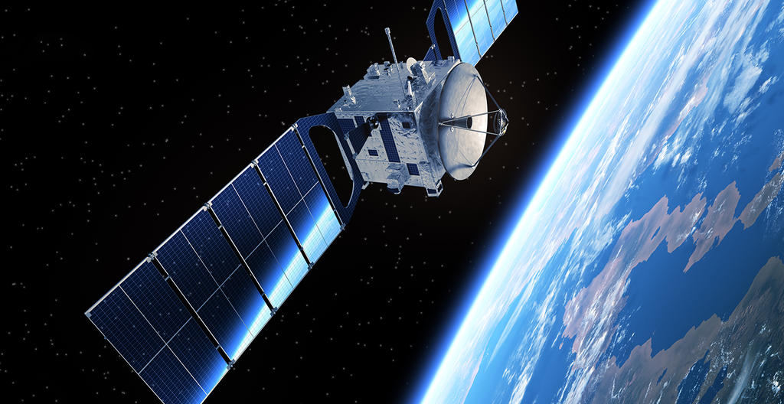

Thermonuclear – An attempt to master the power of the Sun here, on Earth. The process of thermonuclear fusion is opposite to the one used at the moment in nuclear power plants – nuclear fission. It’s cleaner, using the isotopes of Hydrogen for fuel, which are abundant in nature. It doesn’t produce harmful radiation outside the hermetically sealed container or leave any radioactive waste. The reaction is thousands of times more powerful and effective in releasing energy and has the potential, if successfully realized, to power our electrical needs for centuries to come. I’m happy to say that the efforts to build such a power plant are well underway, led by an international project called ITER. There are 35 countries involved, and the site is located in Cadarache, southeastern France, with the goal to have it fully operational by the year 2050.

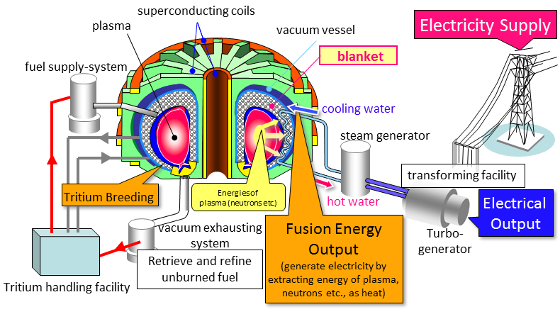

Dark energy – This is more of a challenge for future generations since this type of energy is invisible to our eyes or tools and is still an enigma to scientists worldwide. Its presence is proven through research and observing the trail of influence it has on other cosmic objects and events. It is calculated to represent 68.3% of all existing energy in the Universe. Despite it being so potent, we still don’t have any solid findings around its essence, function, or source. If we manage to make a breakthrough in that area, it’ll elevate the understanding of our world to a whole new level.

   As you can see, there are plenty of possibilities for using renewable energy sources. The ones I mentioned are just a fraction of what human ingenuity and imagination have come up with. Each of them presents a unique opportunity and challenge in its application. The unifying factor is that almost all of them are still in the early stage of their development, and because of that their use is quite limited at the moment. For example, solar panels are still unable to convert most of the energy coming from the Sun – commercial panels have that rate at 18%, going up to 50% for those used to supply artificial satellites with power. Developing, improving, and applying renewable energy tech and different battery types is another step toward a positive change in our society, with the payoff for those efforts being an uninterrupted flow of renewable electricity to every home, installation, farm, factory, hospital, science center, machine, etc. evolving our notion of energetics and giving us the freedom to act with way less negative effects on our nature.

   If you allow me, I’ll take a short detour from the subject and talk about the energy we obtain from the oh-so-delicious meat. Our genius owes to all animals and species that were bred for the slaughter a means of honoring their sacrifice by coming up with a more humane and practical way of procuring what we need. I’m not talking about becoming vegan because that is a choice not everyone can make due to dietary restrictions, etc. Again, the shining light that is technology and the better understanding we have of cell biology is providing us with an answer that will hopefully help us to move away from breeding and killing livestock for meat which is not only immoral but also highly impractical when faced with the ever-increasing population and demand for food. The concept of “cultured meat” is slowly gaining popularity and worldwide recognition for its innovative approach to this issue. It involves taking a biopsy from the animals and obtaining stem cells which can then be “grown” in lab conditions and have the natural ability to transform into actual muscle tissue or fat and subsequently – to mince, steaks, sausages, etc. This technology passed the proof of concept in 2013 when the scientists behind it created the first ever burger with cultured meat, with taste being virtually indistinguishable from livestock meat. The research and development of this revolutionary tech are currently aimed at making the process compact enough to fit in a kitchen appliance so that restaurants and even homes can grow the required meat on the spot without the need for slaughterhouses or transportation. A similar process can also be implemented to grow organs for transplantation, helping countless people around the world. I will again encourage you to do the research if you question the existence of such technology so you can see the extent of our capabilities first-hand.

   3.Architectural designs for cities of the future and a global research of existing and required resources – All the energy in the world and all the different kinds of machines wouldn’t be able to help us unless we have the required materials and know how to use them to create a better way of life and modernized cities with intelligent resource management built into the system. To my delight (and hopefully yours too), such plans have existed ever since the 1960s when Walt Disney himself, worried about the growing disharmony, pollution, and rampant crime that were spreading throughout the urban areas at that time, started working on a prototype city of the future, called “Experimental Prototype Community of Tomorrow” (EPCOT). Unfortunately, after his passing in 1966, the board of directors at the Walt Disney Company decided that investing in urban planning would be too risky a move to make, leaving the last dream of its co-founder without any further development. But as it always happens in our history, when the door of our imagination is open to the possibilities of breakthroughs in our technological advancement and the betterment of our society, it can’t be forgotten or ignored for too long. In comes Jacque Fresco (13/03/1916 – 18/05/2017) – inventor, futurist, social engineer, and dare I say - a true genius of our time. He devoted his entire life to the vision for evolving as a society and a proposition to move away from the monetary system, political approach in governance, and selfish motivations for creativity, replacing them with the resource-based economy I mentioned previously. He also developed complex architectural designs and blueprints for new cities from the base right to the top of every building and installation required for them to function. So another essential step in realizing this plan is to build such a prototype city which will serve as proof of concept to people who question its ability to sustain a population. It will also be an education center for understanding how this new way of life will happen and feel – the pinnacle of what we can achieve with the tools we have at our disposal and a little empathy and creativity. It really is all there, and I’m going to dedicate an entire chapter of this text to their elegant urban structure, but for now, I’ll just point toward the Venus project website again, as well as the movies “Future by design” and “Zeitgeist: Moving forward” for a visualization of the concept. Once such a city is created, it can be replicated and modeled after, using the same base ideas and applying them in different regions. That would be the appropriate time to declare the world’s resources a 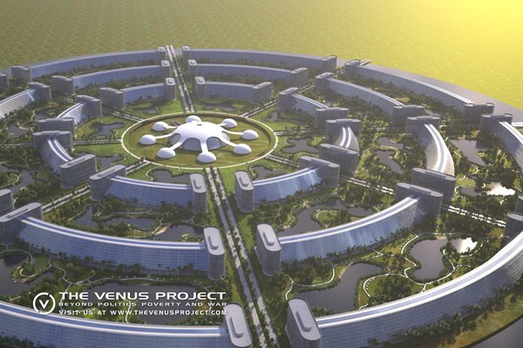common heritage, compile the programs needed to conduct the global research and survey for all of them, and distribute them according to the principles of the resource-based economy. Some of the buildings already exist in Venus, Florida, where the project’s base is located and where it gets its name from. Organized tours and seminars happen every month, and people from all over the world visit to see for themselves, assess what is being offered, and become more acquainted with its essence.

   To quote one of the project’s creators: “This is not a perfect model of social structure.” There is no such thing as perfection since the world is in a constant state of change. But life in society could be improved in a major way and become much more adequate, healthy, and less stressful than it is today.

   4. Evolution of consciousness, thought, and spirituality – The greatest challenge we need to overcome for this plan to work is within our own minds. It derives from the need for a critical part of our society to realize the potential of this alternative, understand it, accept it with all its benefits, consequences, and responsibilities, and request a shift towards it. Without people wanting to participate in this system, it will not be able to function and take care of everyone as intended.

   This is the very reason why I’m writing this text – by revealing our multilayered link with everyone and everything, I hope to show you the bigger picture and help you realize that we need to take care of each other as much as we need to do it for ourselves. I refuse to believe that we cannot change or that there is no other way to live because such shifts in society have already happened numerous times in our history despite the pushback from conservative people and industries that were replaced due to being outdated and obsolete.

   The changes I mentioned so far will help tremendously in this endeavor, freeing our bodies by covering our basic needs and doing away with money, our minds and potential through proper education and a healthy social environment, our souls through spirituality and inner peace. I would ask that every person, who is currently reading this text, to stop and gather as much information as possible on the topics discussed up until this point from all over the Internet or outside it, throughout the four corners of the Earth, to make an informed decision on the matter. Are we truly ready to live in such a place? Are we able to allow ourselves to share the unlimited energy and abundant resources our planet provides? Are we prepared to embrace change and admit that the world is bigger than an individual and we are just a small part of a diverse coexisting multicultural society? If, as I hope, your answer is a “Yes,” then great – that is the way to move forward towards actually achieving this state of existence. If it’s a “No,” then it seems we have more to learn before we are deserving of getting there. It’s my opinion that we owe it at least a try.

   There is another way for people to be driven towards a change in their lifestyle. Due to an inevitable external influence or event, for example, non-renewable energy sources to deplete, drastic and life-threatening changes in climate, contamination of drinkable water, or us deciding to foolishly repeat history, after all, with another world war. These options are clearly undesirable because they need some form of a global cataclysm to propel us to action, which will likely not change things for the better or bring the peace and stability we aim for. Such events can also be manipulated to consolidate the influence and to be in favor of the currently dominating financial elite, which puts us back where we started with zero progress made towards evolving as a society. No outside force can impose a new regime or ideas which contrast people’s will for too long. They will simply replace that with their own vision, understanding, and experience. Real progress can only be achieved when we follow our inner voice.

   Regardless of which path we choose to take, I’m here to show you that the future could be extraordinary and magnificent if we allow it to be such. It’s time to take a peek into this amazing prospect, pierce the veil of time and see what awaits us. What could possibly justify all these efforts?

VIII. The cities

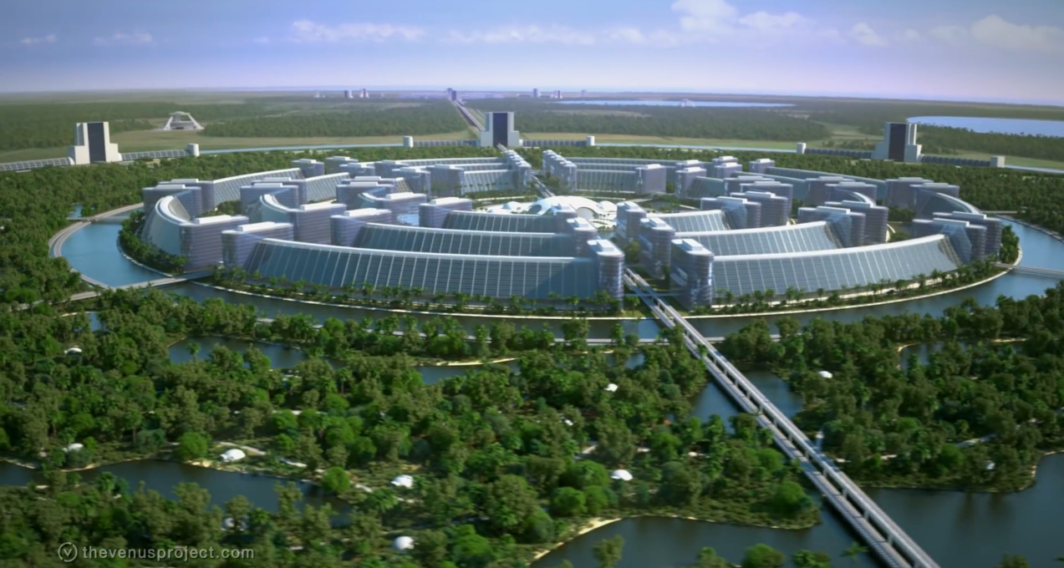

What will a city look, feel, and be like in the future if we apply everything we talked about thus far? With an engineering mindset and imagination, we can form an idea about its essence, outlook, and functionality. I present to you the circular cities.

The center of the circle, the very heart of this complex, will consist of two integral parts – over and underground. Above the ground, the central building will host an information hub where everyone can go and seek assistance with any query that may arise around our everyday urban life or when traveling abroad. There will be user-friendly digital or even virtual stations with knowledge that is shared between all the cities in the world and daily updated by specialists in different areas. That way, people can get the most up-to-date information in real-time, straight from the source, without having to sift through volumes of irrelevant materials to get to it. There will be no separate countries or states and no need for classified documents, secret services, or counterintelligence. In this way of life, people have embraced their interrelation and belonging to the whole of humankind instead of a specific nationality or race. We would prefer to share as much information as possible for the benefit and development of all and receive aid from this international assembly when needed.

The top side of the city center will also host a large forum where all people can present and discuss different topics and ideas for innovation and optimization so that society is always fluent and evolving. This is where issues and questions of public significance will be addressed and resolved with the help of specialists in the area that is being reviewed. Since all people will be taught to be problem solvers in their field of expertise instead of just giving/receiving orders, long-term solutions will be reached much more naturally and quickly. If an idea is accepted as beneficial and improving the quality of living by the people it affects, then it will be implemented as soon as possible and will replace the outdated process. If not, it will be returned with pointers for further development.

And while above ground, all of those vital decisions and flow of information are being shared and deliberated with all the benefits and responsibilities that derive from that, something equally important will be happening beneath the surface. Below the central building will reside the core mainframe computer that monitors and maintains the supporting subsystems of the city – resource management, clean air and water supply, electrical grid, waste disposal and recycling, internet access, infrastructural integrity, and public transportation. It will include state-of-the-art machines that will ensure the consistent work-life cycle of all the different components in this complex megastructure through a series of sensors that will signal if they detect a fault or malfunction. If necessary, the appropriate countermeasures will be taken to resolve the issue swiftly and effectively. The maintenance and repairs will be done primarily by machines. As mentioned in the previous chapter, they will require very little human intervention and will be programmed to handle these tasks. Since the cities are circular, the support grids will be situated along the radials and around the different districts (rings), corresponding with the roads and easy access tunnels if a repair is required. This way, a net will be formed, and the whole urban area will be connected, bringing harmony between supply lines and demand.

Transportation will happen both above and below ground, depending on the type and purpose of the itinerary. From self-driving cars and maglev trains to various land, water, and air cargo and personal vehicles, we will push the limits of what we call mobility. A unifying factor for all of those machines will be using electric motors and obtaining fuel from renewable energy sources, significantly reducing air pollutant emissions. After all, if we completely remove borders, there will be a significant increase in traveling and resettlement, which is simply unsustainable on fossil fuels.

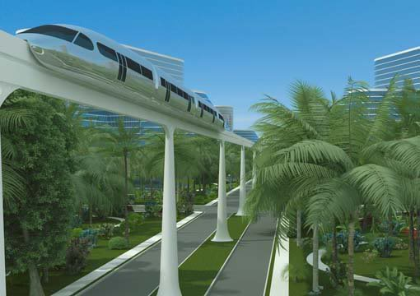

Adjacent to the central dome will be the first circular zone – the commercial district, where you will find hubs for the distribution of all kinds of goods and emergency services, hospitals, schools, restaurants, galleries, museums, cinemas, and other forms of entertainment. Its location is very important because it allows direct access from and to all the other parts of the city. As stated in previous chapters, the highest technological standards and best practices in localized manufacturing and recycling will be implemented so that people can have access to high-quality products without a price tag. If an item isn’t available, a request will be sent for its production, or an effective delivery path will be planned so it can be in use as soon as possible.

Going outward, after the commercial district, come the science research centers. This ring will consist of multiple structures which will house the facilities, equipment, and safe environment, required for experts and researchers in all branches of science to conduct their everyday studies and experiments. This will be a form of creative activity. Through the use of their imagination and vision, given a material expression by cutting-edge tools, these individuals will bring about advancements in technology and our way of life at a never-before-seen rate and scale. I’m sure that having a quiet place to study and dedicate your time to the subject that interests and matters to each of us, as well as the ability to instantly connect and collaborate with other like-minded people worldwide, will be highly beneficial and productive in the long run. With the deepening of our understanding comes an ability to create complex virtual simulations that will provide the necessary testing grounds for the early stages of the research. As a rule, these experiments will be humane a will not cause harm to any human or animal.

After the research centers comes the green belt – a vast field with parks, playgrounds, recreational areas, as well as all kinds of sports and fitness equipment. This ring will be the metaphorical lungs of the city, clearing the air and providing balanced access to both intellectual and physical activities. It will also serve as a base for those who’ve dedicated their time to the practice of sports and will contain all the necessary facilities for them to do so.

Beyond the green belt lies the residential area. Each of us will have a choice between different styles of self-sufficient houses or apartments with multiple amenities.

The individual dwellings can be prefabricated from a new type of pre-stressed, reinforced concrete with a flexible ceramic external coating that facilitates maintenance, is fireproof, and impervious to the weather, ensuring minimal damage from earthquakes and hurricanes. Their shell construction can be mass-produced in a matter of hours. Structural elements will be flexible and coherently arranged to serve individual preferences. They could be built anyplace one might imagine - amidst forests, atop mountains, or on remote islands. These dwellings can be designed as self-contained residences with their own thermal generators and heat concentrators. Photovoltaic arrays would be built into the skin of the building and into the windows themselves. Thermopanes would be used to tint out the bright sunlight by variable patterns of shading. All these features could be selected by the occupant to supply more than enough of the energy required to operate the entire household. Each dwelling will be surrounded by beautiful gardens, lakes, and lush vegetation, which will also help distance it from others in the area.

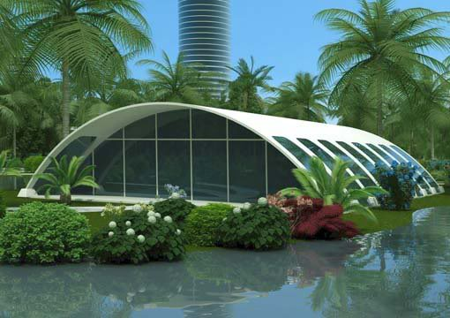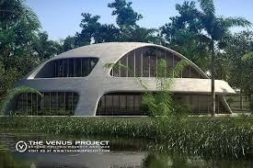

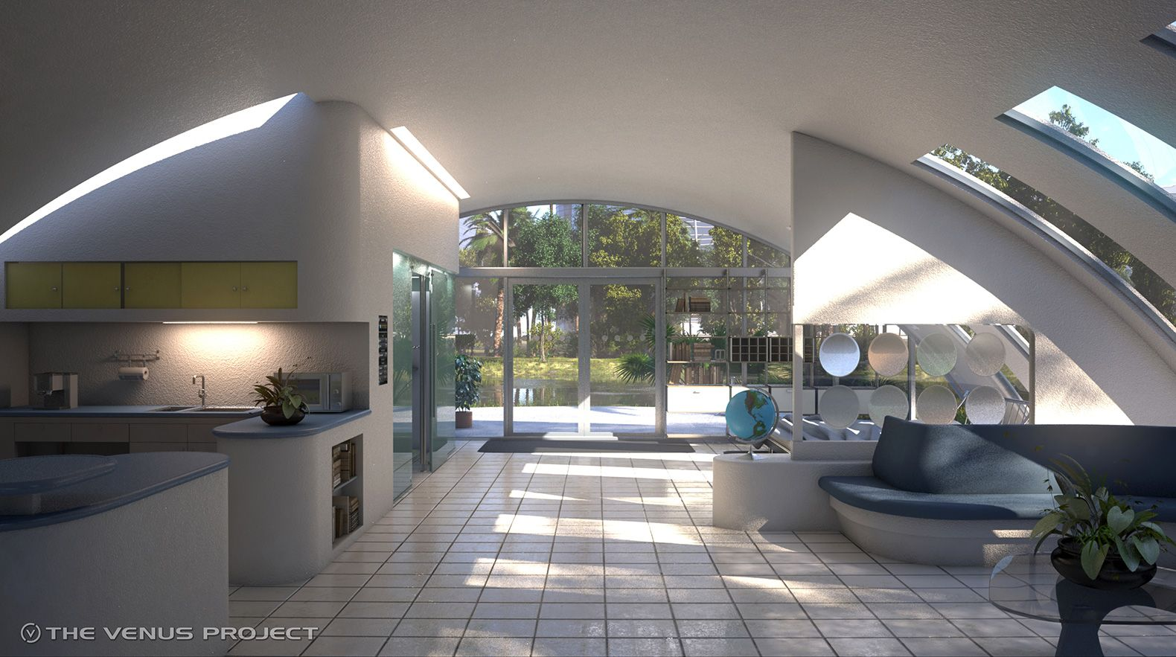

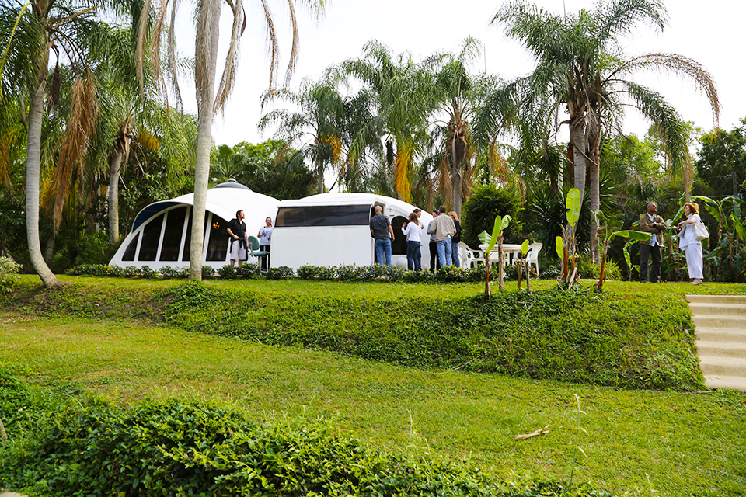

Apartment buildings will use the same principles and will be built by mega machines designed for construction purposes. The significant advantage of living there will be that a skyscraper or a flat complex will contain all the everyday necessities of the inhabitants and provide easy access to stores, centers for first aid or education, restaurants, fitness, recreation, entertainment floors, etc. Imagine it like an all-inclusive stay at a hotel but without having to leave at a certain time or pay for the services.

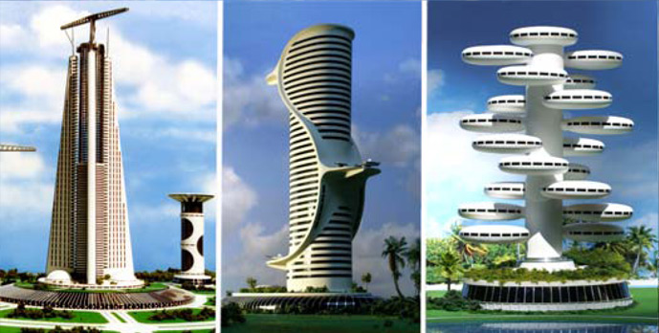

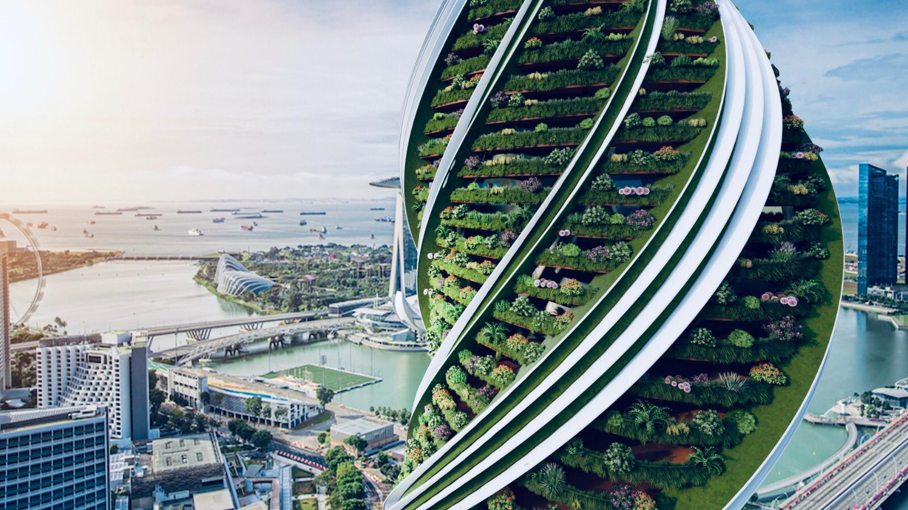

In the outskirts of each city will be the installations for producing clean energy, the type of which will depend on the geographical opportunities of the area. Hydroponic, aeroponic, and aquaponic systems, as well as an agricultural belt, will help cultivate various useful plants that will provide fresh fruits and vegetables. Implementing the latest technological advances to achieve a controlled environment will remove the need to use pesticides. This part of the city will also be great for practicing sports and other activities that require vast open spaces.

This architectural design is just one of many envisioned and created by Jacque Fresco. There also exist plans for cities underground, underwater, and floating cities in the sea which bring balance between the available space and the population’s growing needs. It’s all part of the Venus project - the fruit of lifelong planning and the labor of its volunteers. Much more of both will be necessary in order to bring it to existence. A fitting first step is the Center for resource management which is currently under development. It will present an education center, studying various approaches to restoring the Earth’s collapsing ecosystems, as well as testing grounds for all the ideas and concepts of the project and this new social structure. Such a facility will serve as a beacon of hope for the future and will help propel our evolution towards this way of life.

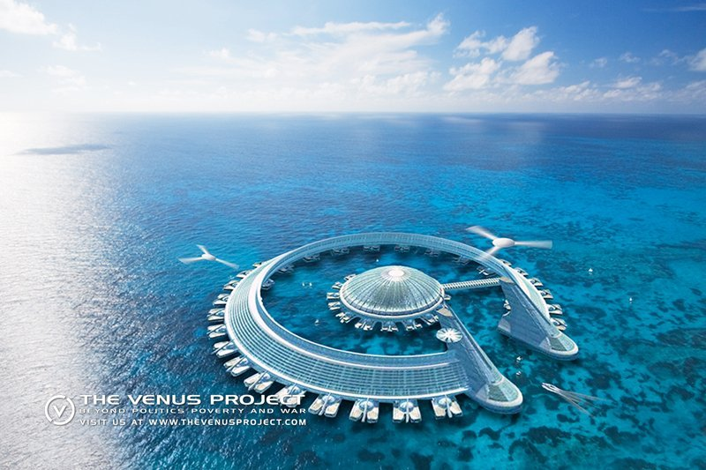

IX. Creativity

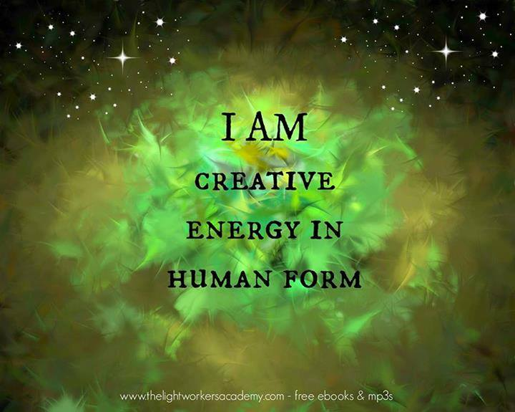 So now that we know how the cities of the future will function, it’s time to answer another big question that’s on our minds – what will we do with our lives in a system that doesn’t involve any financial incentive? Maybe we’ll finally have the opportunity to relax and breathe a sigh of relief after the thousands of years it took us to get to this point. Wouldn’t it be nice – to pause for a while and be thankful for the system of sustainable abundance we managed to achieve and just let it take care of our needs while giving ourselves a break? That would do wonders for the physical and mental state of people who will be, at that point, several levels up on Maslow’s hierarchy and will look at the world as more than a mere struggle for survival. The path towards pursuing higher goals will be unlocked.

   I’d like to quickly address a counterargument that claims in such a social structure, people would become lazy, lose their motivation and identity through excessive indulging, and lack of will to improve. I agree – there is a real risk of that happening, just as it exists today. After all, it’s unreasonable to expect everyone to be equally productive and creative. Nowadays, we have so many ways to get distracted, and yet with more options available, innovations are happening exponentially. Even in my case - I’ve chosen to write this text instead of all the other things I can do with my time. Why is that? I believe that with the appropriate education and personal example that encourage creativity, spontaneity and freedom of expression, empathy, and a sense of belonging come higher needs that can’t be satiated through consumerism. I’m talking about the need to recreate our inside world and give it a physical form so we can show it and pass it on to other people; the need to face and overcome new challenges and obstacles while growing in the process; to go on new adventures, be curious, discover new horizons and find answers to the countless mysteries of life; the need to contribute and leave a respectable legacy to society. All these sources of motivation have accompanied us since the dawn of civilization. They have the power to push our progress ever forward and upward if the social environment supports, empowers, and puts focus on them.

   So let me illustrate with a few examples of activities and endeavors we’ll be able to practice and undertake in this way of life:

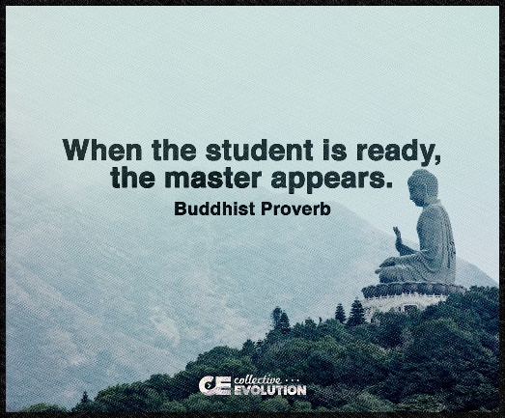

1.Studying/Teaching – Learning new skills and gaining further understanding should always be an accessible option. Throughout our life, we become interested in many different topics, and the need to expand our knowledge will be reinforced by society and the educational system I mentioned in Chapter II. I promised to talk about the teachers, and now is the time to do just that. There will be two types – professional educators and practitioners. The first type will be people who have studied pedagogy along with the subject they teach, care for the development of children or adolescents, and want to help with their growth and self-actualization. They will lead the theoretical part and organize some practical exercises, at least in the early stages of learning. When a student begins to show potential and sparks of creativity in a particular discipline, they will start to interact with the practitioners as well – people who have years of hands-on experience and have achieved some form of success in their field of expertise. Their relationship will be similar to that between an apprentice and a master of the craft. These lessons will occur in the dedicated workspace of the practitioner at a previously agreed time. They will introduce the student to the actual day-to-day tasks, responsibilities, and unique techniques, making them a part of the creative process. As I mentioned before, this will be highly beneficial for the person who’s yet to decide if they want to continue in that field or not. And if we look at it from the perspective of the teachers, imparting our knowledge and experience in our favorite discipline to a new generation of curious minds could be quite fulfilling, enjoyable and will encourage many people to voluntarily accept this vocation and train students.

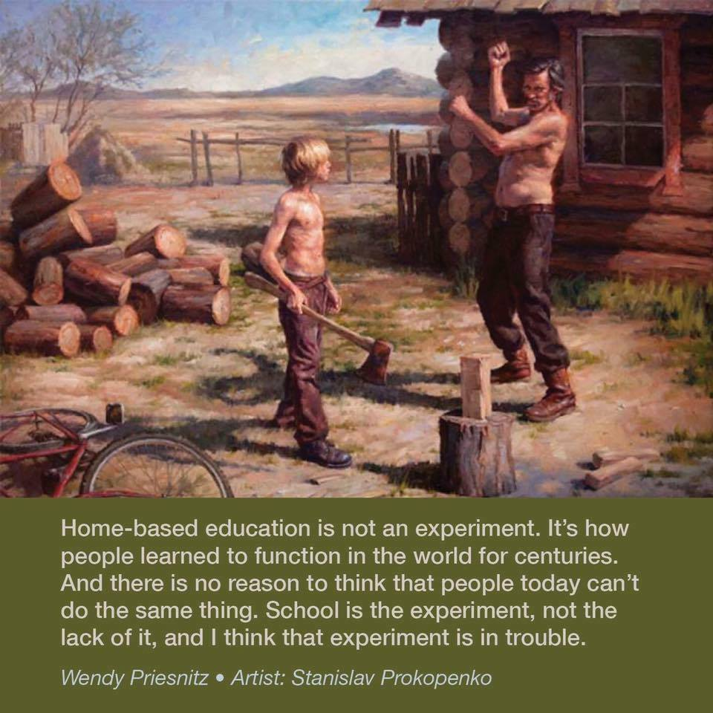

2.Scientific research and progress – from Medicine, Physics, Biology, and Chemistry through Pedagogy, Linguistics, Psychology, and History, to Computer science, Mathematics, Mechanics, Astronomy, Cosmology, etc. - all of the different branches of science will be available for study and development in the city research centers. Just imagine the possibilities and new heights we can achieve when scientists have reliable equipment and the freedom to conduct their work unburdened by financial issues.

3.Technological advancement and maintenance of the essential systems – If we plan on putting our resources and wellbeing even partially in the hands of machines (which, by the way, happens very often even today), then we’ll have a global need for technically oriented individuals who enjoy working with and are willing to support these systems through their efforts and problem-solving skills. These people will perform the creative task of inventing new types of technology, upgrading and modifying the existing ones to help resolve the issues of today and tomorrow, and writing all the complex code/programs that will be required for their correct, efficient, secure, and safe operation. The technical experts will also be the first responders in case of any failure in the essential systems, finding the reason behind it and providing solutions to restoring the functionality as quickly as possible while ensuring safeguards are in place to prevent future incidents. As mentioned before, the machines themselves will have protocols for self-diagnostics, maintenance, and repair, but it’s always good to have a plan B in case of an emergency. This will clearly be a big responsibility, and a lot will be expected from anyone who decides to devote their time to our technological advancement and security. However, there is another way of looking at it as well. Do you think there will be people happy to step up and improve or support the technology that provides us with food, clean water and air, clothes, shelter, and the tools and goods we need to function as individuals or as a society? Naturally. I can tell you right now that I would gladly be one of them.

There is another bold endeavor that people can undertake and accomplish through international collaboration. It’s more of a challenge for future generations, but there is progress being made every day, and I’ll mention it so that it can pique your curiosity and spark conversations in that direction. I’m talking about the development of nanotechnology and achieving the synthesis of organic life and synthetic matter. All in the name of enhancing the human experience, for example, by aiding regeneration and healing, replacing lost limbs, elevating strength and cognitive/brain functionality. If you feel like giving transhumanism a chance, you can even go all the way and upload your consciousness to a new organic or mechanical body of your choosing. Nowadays, this incredible concept has left the realms of fiction and is the core of many scientific publications, discoveries, and practical research into the various beneficial applications and risks of creating a link between humans and machines. We no longer ask: “If it’s possible?” but are in the process of answering: “How do we make it happen?”. Given our everlasting desire to evolve and become more than what we were before, I am positive that it’s just a matter of time and effort for us to transcend the current notion of humanity and go far beyond our wildest dreams. It’s both exciting and scary to think of what we can achieve if we put our minds to it. With the risk of repeating myself, it is essential that in times like these, we keep our morality in check and make sure that we understand and accept the importance of our interrelation, diversity, and the constant need to help each other for the betterment of all. Otherwise, there is a likelihood that we’ll carry our misconceptions into the future, begin a new cycle of structural violence, and sow chaos, destruction, and misery on a global scale. In other words, we need to prepare and ensure that we are worthy of this metamorphosis. Only then will it flourish into a positive change for our society and lead to a better life and a higher way of existence.

  4. Sports, Art, and Spirituality – Our creativity isn’t limited to just teaching and exploring new and different aspects of science or technology. It draws inspiration from the daily interactions between our inner and outer world, taking many beautiful forms like music and songs, dancing, theater, opera, cinema, literature, painting, graphic design, applied arts, culinary arts, martial arts, fitness, training sports, practicing Yoga, meditation, seeking spiritual enlightenment and so on. Each of these activities stimulates the unique creative energy within our body, mind, and spirit while testing and expanding our limits. They help us express the truth inside, gain new abilities, experience personal growth, and deepen our understanding of the self and its significance to the world. When shared, they also make others a part of this transformative journey.

   As you can see, there will be plenty of ways to create and be productive in such a society. This is not an exhaustive list, and people will be free to devote themselves to any of these noble causes entirely or alongside other activities that represent a point of interest. Their practice will form an environment that will encourage working in a safe and healthy way, mutual respect and collaboration between the different disciplines, as well as succession and continuity through apprenticeship. All of this will be done not through the negative incentive of greed, consumerism or fear for our survival, but as a celebration of our boundless potential, a triumph of the human mind over matter and an acknowledgement that we can break through our limits and use our Divine spark to build a better tomorrow.

   The time for performing these activities will be determined individually, based on what we know to be our peaks of creativity during the day (for example, in my case, it’s in the morning). For the rest of the time, we’ll be able to take care of our family, practice hobbies, attend social events, travel around the world, engage in entertainment, or visit recreational facilities. All of this will help balance physical and mental activity, as well as recharge our energy. When creativity is in harmony with the preferences and needs of the individual, it will lead to a more fulfilling, exciting, and healthier life.

X. Destructive behavior and rehabilitation

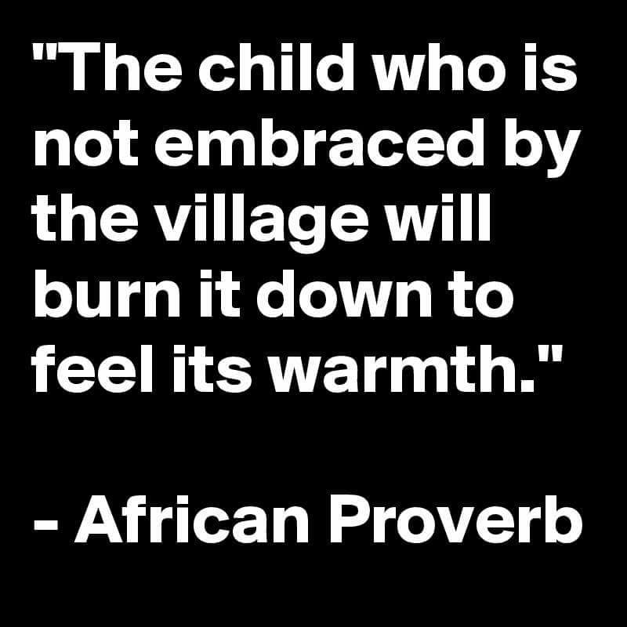

Finding a positive and humane way to deal with people who, at some point in their life, committed violent or disruptive acts is a very ambitious endeavor that will take all of our collective skills and ingenuity to achieve. The text you are currently reading is my humble contribution to this effort. Everything I have written about so far has been in the name of reducing overall crime rates by changing the factors that are proven to cause the need for such behavior. The very principle I mentioned at the beginning about the sanctity of life and our interconnection, when understood and taken to heart, should be enough to cease all hostility. But that’s just a bit of wishful thinking on my side.

From our point of view, it is hard to imagine what kinds of deviant behavior will exist in a world without money or borders. Nevertheless, the social benefits far outweigh any possible risks, and, as you’ll see, there will be processes in place to resolve such matters effectively. Just to put things into perspective – overcoming the monetary system and consumer mentality through implementing a resource-based economy will eliminate the financial motive for criminal activity. That is a decisive victory over corruption, trafficking, theft, and organized crime syndicates which seem to be growing like cancer in our current society. As an added bonus, this change will finally put an end to the countless disputes over who gets what amount of paper. Moreover, with proper education, focusing on problem-solving, empathy, and analytical thinking, as well as the freedom to travel anywhere we want and create without constantly worrying about our survival, we will achieve more successful, self-aware, reasonable, intelligent, and emotionally stable individuals. This, in turn, will lower the rate of violence, hate, and crimes of passion. No borders means we are all part of the same society, so wars and crimes against the state will lose their logical basis and become unnecessary. Multiple active processes will ensure the support subsystems of the cities will operate safely and correctly, undisturbed by anyone with destructive intent. In case of a malfunction or a breach, immediate countermeasures will be in place to restore functionality and repair any damage. Analysis will be conducted to find a way of avoiding similar incidents in the future. This will greatly discourage any vandalism or hacking attempts.

It is my strong belief that in such a social arrangement crime rate will see a significant decrease in a natural way due to us removing most of its catalysts. In other words, if people don’t have the predisposition and incentive to commit violent and disruptive acts, they simply won’t because there is no reason for it. Studies in the field of behavioral psychology show that violence and wrongdoing aren’t innately found within us but are learned throughout the course of our development. The same principle applies to constructive behavior and healthy relations. That being said, to have the whole picture, we need to explore the possibility of these isolated cases of criminal activity, give them the attention they deserve, and resolve them with care for the benefit of all.

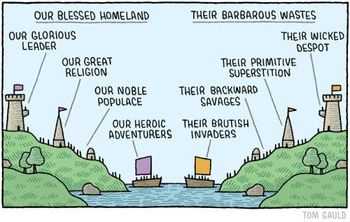 So let’s take a quick look at the mechanisms we have today for dealing with destructive behavior and determine if they are worth perpetuating in the future or if there is a more adequate and civilized alternative. Nowadays, we have seen enough man-made horrors - witnessing or participating in the atrocities of two world wars, countless local conflicts, military or political dictatorship, forced inequality, and repression. The rising international society has taken major steps towards establishing global peace by creating multiple supranational organizations (like the United Nations) and signing treaties, declarations, conventions, etc., reinforcing and reflecting our will for collaboration and resolution to our disputes through diplomacy. Coupled with the flourishing new ways of developing international relations in our modern society (technological or otherwise), these efforts should be enough to prevent us from repeating our past mistakes. And yet, military aggression, dictatorship, stereotype-based hate, and false flag operations continue to occur, creating new horrors. They could be artificially inflated or hidden by certain media outlets, depending on the personal goals of the ones spinning the narrative, but nonetheless, they are very real. Similarly, national and internal laws do not prevent anyone from directly committing criminal offenses. They only punish those who have already done the deed. Sentences are passed by people who mostly don’t care about solving the bigger social problems and have no tools to find or change the deeper circumstances that influenced the individual to engage in illegal activities, but instead blindly follow the letter of the law and support the status quo. On top of that, judicial systems are one of the most corrupt institutions in our society, secretly controlled by the astronomical amounts of bribes or cruel extortion that come with successful criminal enterprises. In truth, legislation and diplomacy could only be as good, just, and adequate as the people who participate or are affected by it. If a person finds a good enough reason to break the law or abandon morality, they will do just that, even if the consequences are severe and unfavorable to them or others. Prisons are proven to have a negative effect on the human psyche by traumatizing the inmates, making them feel hopeless and stigmatized, introducing them to other criminal elements, abuse of power, and in most cases – leading them to continue down the same path. To me, today’s justice system works similarly to a doctor trying to cure a medical condition by masking its symptoms instead of applying the correct treatment.

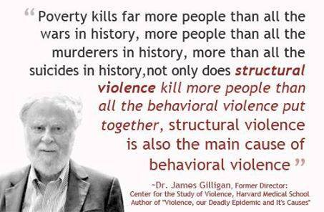

Therefore, the goal of our future society should be to collectively find the specific reasons that cause an individual to resort to harmful behavior and make personal, local, or, if necessary – global changes to prevent that from happening in the future. A proposed step in that direction is to substitute the punitive aspect of our justice system with a new, different, and more humane approach. Instead of paying fines or serving a jail sentence, the perpetrators of destructive acts will temporarily inhabit housing complexes that will resemble a mixture of a school, a training ground, and a center for applied psychology. There, each resident will work daily with a personal psychologist and assistant. Together, they will get to the root causes of the destructive thoughts and actions, participate in additional education tailored to their individual needs, find a way to bring positive change, and channel those impulses into a better outlet. During this process, people will acquire a deeper understanding of themselves and focus on rehabilitation, healing their relationships with close relatives, and finding a new purpose within society. Through honest dialogues, empathy, and a careful examination of their inner world, motivating factors, and outer expressions or actions, these two individuals will build an environment of trust where they will be able to find the source of problems that led to the manifestation of destructive impulses. They will also develop appropriate preventive techniques and actions that will help avoid such situations in the future. During their stay, people will be able to keep in touch and see their loved ones, access information from the online database, and all possible amenities and tools to create, given the situation. There will also be training grounds and facilities for maintaining physical fitness. This sensitive and delicate process will continue until the offender shows a complete understanding of the inner mechanisms that lead to harmful acts, sincere determination and will to reject that behavior in the future, and a clear path to achieve that. At that point, they will reintegrate into society and move on with their life while continuing to meet with their personal psychologist on an agreed regular interval to ensure they are able to overcome and channel their negative energy into creative and beneficial actions. Even today, the correctional facilities in Norway use similar methods for rehabilitation, with the result being the lowest recidivism rate in the world.

But what if a person can’t be reasoned with due to a mental disorder? In such cases, as you can imagine, these individuals will be treated by medical professionals in state-of-the-art facilities that provide personalized and humane treatment and a safe environment for both patients and staff. There will be large gardens with fountains and relaxing music which have a scientifically proven therapeutic effect in such situations (as evident, for example, in the Health museum in Edirne). Patients will be able to express their creativity and access information. They will stay close to their relatives and away from situations where they can hurt someone.

Even though we aren’t able to predict the future yet, it’s safe to say that in such a highly evolved and civilized society as the one I’m describing, there will be zero tolerance for destructive behavior and overwhelming demand for a lasting resolution in every instance. I can only hope that we will reach a state of living that will transcend the misunderstandings, greed, and violent impulses that cause most crimes today. It will be good to see them left in the history books, works of art, and entertainment as examples of what not to do going forward.

XI. Other controversial topics

Now that we explored most aspects of living in the future and possible changes from today’s society, I would like to turn your attention toward several topics belonging to the realms of the so-called “moral grey area.” Their controversial nature comes from releasing the hormones of happiness (like dopamine, endorphins, and adrenaline) when engaging in such activities. This makes them easily and intensely addictive, with the dangers of serious harm to our health, moral degradation, and even loss of our life if practiced incorrectly or with negative intent. For those reasons, we need to have temperance, self-control, and guiding principles when dealing with matters of this sort. I will share with you my point of view on these topics through the prism of this proposed social metamorphosis. As always, I’ll let you decide if my thoughts are flowing in the right direction.

1. Sex – Mother Nature did really well when it comes to ensuring we have an offspring. The mating instinct and the desire to continue the species is one of our strongest drives, second only to self-preservation. We can observe an impressive range of different ways of attracting a partner, spreading seeds, and taking care of younglings, even if we look only at the plant and animal kingdom. Clearly, this longing is rooted deep in the genes of all living creatures and is strong enough to overcome us and completely alter our behavior during the mating seasons. All of this is in full force when it comes to us humans. Our evolution and self-consciousness have made this process much more complex by adding our individual desires, psyche, and character to the potent chemical cocktail, which drives us towards looking for a partner in life or for the night. The multitude of fixations, complexes, repressed emotions, personal example from parents or lack thereof lead to the formation and outer expression of an infinite number of sexual desires, some of which could be considered quite bizarre. It is my guiding principle that whatever they are if practiced by consenting adults with the required preparation and safety measures in place, they should be acceptable, and if not – they absolutely shouldn’t.

It is hard to write about such personal and private matters, but some issues affect us all, and I would like to address them in this text.

We are being manipulated in many ways because of our sexuality and gender. From faraway faces on the screens of our devices, billboards, ad campaigns, entertainment programs, and many different forms of art to our own family, friends, neighbors, and partners – everyone seems to know better than us the role we are supposed to fulfill, the feelings that we need or not need to feel, the possessions we need to have, and even our behavioral patterns just because of our sexual preferences. Every day we are being bombarded with messages and signals which consciously or not 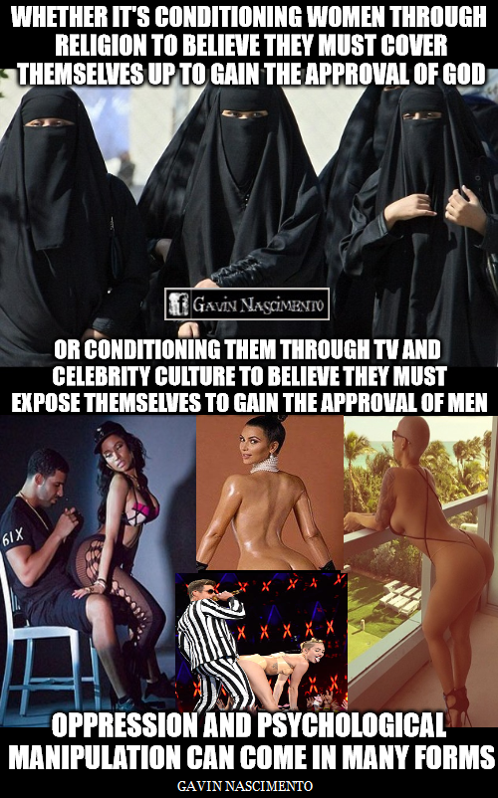turn our attention towards sex and erotic themes. In the Era of information, this topic is omnipresent and elevated to a cult. As one of the fundamental functions in our life, it’s completely understandable why we would draw inspiration from this subject and discuss it so often. We need to keep in mind, however, that oversaturating the brain with sexual or suggestive images and undertones isn’t healthy. Multiple studies on sexual drive and stimuli have shown that overexposure to such material has the effect of shifting our focus away from other thoughts and towards lustful desires, which, if left unfulfilled, cause tension to build up in our minds and bodies. As a result, that could be the basis for acute stress, demotivation, forgetfulness, irritability, depression, and various irregularities in the organism.

I think you would agree that the advertisement and show industry do us a great disservice in this aspect. Creators in these fields went very far in their efforts to convince people to choose and consume their products. After extensive research into the processes which determine decision-making and forming an opinion on a subject, the clear conclusion is that the most direct way of circumventing critical thought and making a person act spontaneously and irrationally is to get us to be emotionally invested in whatever is being offered. Powerful emotions and feelings determine our desires and, by extension – our aspirations. It’s almost impressive how successful ads and pop culture can be in manipulating our decisions. The goal is to provoke an almost unconditional reaction in our minds that the product should be owned, seen, heard, etc. because it makes us feel stronger, more beautiful and desired (even though these qualities are quite subjective), part of the community, filled with all sorts of emotions, cooler (whatever that means) and of course – happier. In most cases, the messages that are being conveyed have no direct connection to the actual commodity or reality for that matter but instead aim to put us in a fleeting state of trance, making us more susceptible to their influence. It is a bit scary to think what other subliminal information could be relayed to us through the same outlets and methods even now. The ability to control our emotions is truly being tested with such constant intrusion into our personal space.

As you can imagine, one of the best ways to stimulate our senses is through the promise of sexual gratification. It could be a beautiful model, faking the use of a specific product, a group of provocatively-dressed people in a music clip or a movie, carefully placed images or inscriptions with sexual undertones – this sort of manipulation has reached alarming proportions. I understand the motivation of those who push for this type of representation – to accept their brand as an attractive choice and move towards what they offer (be it their ideas, material items, or the people themselves). And it evidently works nowadays since corporations pour millions and even billions of their assets into advertising their goods and services exactly this way. Apart from the desired effect, however, this whole hailstorm of sexual manipulation has a strongly negative consequence. In a broader aspect, it creates an entire culture of people who just don’t care about the bigger picture and, like mindless zombies, aim towards purely physical and superficial relations with the goal of instant gratification, rationalizing existence in the most direct way – through a simulated intimacy. In this situation, sex is equivalent to a workout with a partner and a natural drug, which gets more addicting with every subsequent encounter. It’s a vicious cycle that is sometimes quite difficult to cast off.

But lust isn’t the same as love, and physical closeness doesn’t mean a real attachment. In a healthy relationship, sex is the culminating expression of feelings that exist in every interaction between the partners on a physical, emotional, and energy level. An everyday task done together, an intimate conversation or even just the unique presence of a loved one with a pinch of creativity is enough to show and reinforce the desire for mutual affection, which means so much more than physical attraction. Some would say that these relationships are rare and not always possible. I agree with that, but the fact of the matter is that they exist. I have experienced and witnessed it with others close to me as well. Such a bond completely justifies all the searching, waiting, and efforts made to achieve and maintain it, bringing feelings of bliss, elevation, and ease when dealing with life’s constant challenges. А strong connection like this is far superior and preferable to faking affection to gain wealth, status, or temporary satisfaction because insincerity always has a counter-effect. It makes the relationship feel forced, like a burden or a role where you play someone else and, as a result – alienates the people involved in it. On the other hand, having a genuine attachment with trust, admiration, and a mutual desire to give pleasure positively affects both the physical and emotional state of the partners in multiple ways, like boosting the immune system, faster healing, improvement in mood, having a feeling of belonging, contentment, confidence, happiness, and hope for the future. As strange as it sounds, this is all scientifically proven to be true.

In the proposed version of the future, sex will be an open topic for discussion. It will be accepted as something completely natural (which it is) without parading excessively with it or with sexuality as a whole for the aforementioned reasons. We will overcome the primitive shock of mentioning it. As a society, we will evolve to be more mature and more effective in expressing our emotions and desires, as well as controlling them when necessary. There will be plenty of information on the subject for those who are interested and wish to seek it, just as it is today. If younger children ask about it, we can simply answer that it happens when grown-ups who aren’t related love and feel attracted to each other. Adolescents will be taught the anatomic mechanisms, principles, and processes that occur while having sex, ways to ensure safety during intercourse, as well as the emotional effects it has on the partners. It will be explained that there are benefits, but also responsibilities to it and in that sense should be practiced with someone who wants it as well, whom we choose and deem worthy by our standards.

Moreover, we all need to understand that not every two individuals are compatible with one another. In some cases, the partners will appreciate and uplift each other, and in others where this is almost completely missing. It’s only natural that sometimes we’ll face rejection or certain relationships won’t work out. That doesn’t mean we are less than other people, but it shows us we need to search in a different direction. Being able to live as an independent individual is equally important and deserving of our attention as our interrelations. In this regard, studying empathy and emotional culture can help immensely, bringing much-needed clarity and understanding in moments of vulnerability, conflict, or heartache, and sometimes – even in well-balanced relationships.

I want to end this section by briefly addressing the institution of marriage. In my opinion, such an official declaration of union isn’t essential when a stable relationship exists between loved ones. I don’t mean the religious, spiritual, and cultural ceremony, but rather the legal construct of marriage. In most cases, it’s just another institution that serves to unnecessarily complicate and monetize an otherwise natural interaction. Try going to your beloved and telling them: “I love you so much that I want to involve the state and government in our relationship!”. Sounds ridiculous, doesn’t it? But that is the reality of the situation. Civil marriage has never been, isn’t, and never will be a guarantee for fidelity, devotion, and commitment towards the family. If a person finds a good enough reason to betray their trust or leave, they will do that regardless of whether they are joined in matrimony or not. On the other hand, if the affection and attraction between the partners are real and sincere, they will hardly need the bonds of marriage to express and uphold that connection. Anyway, if such a step makes the spouses happy, they will be free to do so. As one of the most personal decisions in life, it should always be a conscious choice of an adult - arranged or coerced marriages have motives that are obviously quite different from the mutual happiness of the couple.

As for having children and taking care of the next generations, I would say that we live in a world where we don’t need to breed like rabbits. Around 7 billion and 900 million is a serious number that represents the world population at the moment. By my understanding, in this situation, it would be unreasonable and irresponsible for a couple to have more than two kids who can continue their bloodline and carry their genes into the future, but again – this is a strictly personal choice. Above all else, parents need to ensure an environment with the appropriate conditions to raise a healthy child and teach it to be curious and inquisitive about the world, give it the psychological tools to be problem-solver, and accept people from diverse backgrounds as part of the global society, while exploring its own unique needs and talents. This will help our growth as a worldwide community by encouraging the development of strong, positive individuals with clear goals and a willingness to take on the challenges of today and tomorrow together.

2. Drugs and other sources of addiction – Admittedly, I have a bit of experience when it comes to being addicted. I had a heavy dependence on a medication I was receiving to the point that even after I was cured, my brain was still telling me that I needed it and was even falsely manifesting the symptoms of the disease. Since I could easily buy it at the pharmacy without a prescription, I kept getting and ingesting it without consulting with my doctor, not realizing the harm I was causing to my body. Gradually, I started to suspect that something was off and went to my general practitioner, who, after examining me, immediately prescribed a placebo which didn’t affect me in such a negative way. There was a noticeable difference within a week, and eventually, I stopped taking medication altogether. What was, in my eyes, a severe condition that I needed to treat for months turned out to be my mind playing tricks on me.

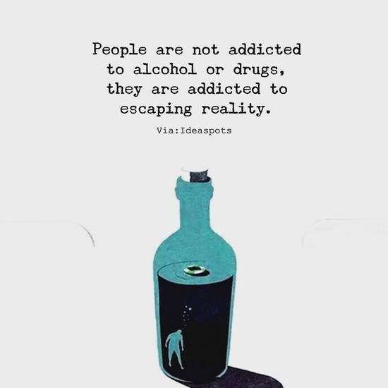 Addiction is like being trapped in a prison of our own making. It narrows our vision and imagination, significantly reducing our will to change. While serving as a temporary way to escape our problems, it never truly presents a resolution. It actually makes things worse by further complicating the situation, damaging our health and ability for critical thinking, lowering our self-control, and alienating us from our loved ones, the rest of society, and even reality. The only way out is to completely renounce the source of dependency and take steps to avoid this vicious cycle by altering our perception and behavior towards it.

Addiction could originate in far more than just the drugs and substances that cause us to hallucinate or feel euphoria, calm us and slow down or excite us and stimulate specific processes in our brains and bodies. There’s also abuse of medication, alcohol, cigarettes, Internet and information dependency, video games, gambling, anger and violence, food, and even obsession with certain people/relationships.

Each of those presents a unique challenge to overcome, but with the implementation of the Resource-based economy and the removal of money from the equation, the situation will change so drastically that some of them will no longer be a concern. Gambling, for example, will still exist but will be conducted with chips or virtual currency, keeping that exhilarating thrill and feeling of being a winner without the risk of ruining our life over losing a bet. Taking the profit away from the distribution of medication will do wonders for the pharmaceutical industry and finally return the focus of this endeavor towards healing people, instead of the corrupt practice of making a fortune from selling pills (that may or may not be necessary) at the expense of sick and elderly folks.

When it comes to the currently outlawed substances, there is a very elegant scientific solution that we could implement. To my surprise, while researching and reading up on the subject, I discovered that when micro-dosed correctly, many of these so-called “illegal drugs” have proven positive effects on several neurological and mental disorders. In light of this information, it would be appropriate for scientists to conduct thorough studies on how they affect people. After we have a clear understanding of the boundaries within which we can use them safely, they will become available for doctors to prescribe in instances where it is possible or necessary. This will be a valid option for both medical and recreational use. As funny as it may sound, we will be able to go to a medical practitioner and tell them we want to take substance x, y, or z. They will either refuse due to likely adverse effects in our case or give us a prescription for a certain amount based on our current health, age, weight, etc., while also advising on the correct frequency of intake and any safety measures we need to ensure beforehand. If this sounds a bit scary, think about the current alternative. Drugs aren’t being tested, regulated, or approved for use, but instead are completely outlawed, which causes whoever sets their mind on trying them to buy from the black market and, as a result - finance criminal enterprises and risk their health and lives. I think you would agree it is preferable to have the safety, clarity, and medical control that only an expert in the field could provide.

Let’s talk about smoking cigars and cigarettes for a bit. The core principle of this society of the future proclaims the sanctity of all life, which contradicts any actions that would cause harm to ourselves or others around us. And that’s exactly what tobacco cigarettes do – they cause serious damage to the smokers and everyone in their proximity. There are zero positive effects - even the fleeting sensation of calm is quickly nullified by the perpetual craving for the next hit. I understand that the habit of smoking usually starts because of the overwhelming amounts of stress and anxiety nowadays or through pressure to conform by adults or peers, but that doesn’t justify the inadvertent loss of time, resources, health, and human lives, as well as the conscious pollution of our environment. These people even think they are showing “class” by doing this when in reality, they look like overgrown babies that still need a pacifier to calm them down. It is my stance that such a blatant display of lack of will should remain only in the history records. Even today, there are multiple ways to overcome this addiction, like consulting your doctor about it. The reader is free to disagree if it’s deemed that my opinion lacks merits. By writing this text, one of my aims is to make the world of the future a calmer and healthier place so that such behavior isn’t intuitive or necessary. There will be many more positive ways of recreation and passing the time, apart from inhaling and blowing harmful smoke.

Finally, I would like to mention a new type of technology that could do wonders and bring a new era in the way we interact and communicate with the world and each other. It can also become a very powerful source of addiction – virtual reality (VR).

 Recreating the world through an individual’s unique perspective isn’t a new idea. Inventors, artists, writers, and philosophers have continuously transformed their life experiences creatively for thousands of years. In the last few decades, with the ever-growing capabilities of technology, people started to do that successfully within the digital matrix. The first attempts at creating a virtual reality were modest but also bold for their time (the middle of the 20th century), managing to engage only our sight through visual stimulus on the computer screen. But even a tiny glimpse into this new world was enough to unlock our curiosity and exploratory desires, making us want to spend a little more time in this digital universe, despite its obvious disadvantages and bugs. Soon after, we included hearing and touch through the use of speaker systems, keyboard and mouse, joysticks, electronic musical instruments, steering wheels, mock weapons, etc., getting us ever closer to what we know to be real. There are various projects for creating haptic suits, multidirectional platforms, and devices to help us navigate and experience this simulated environment with our full senses. We are now approaching the moment when we will be able to metaphorically “enter” the virtual space.

Think of the possibilities. For starters, imagine the additional nuances of virtual communication when we are able to not only see and hear the other person but also read their body language and feel each other’s touch. I’m sure that anyone who’s been in a long-distance relationship will appreciate the idea. This digital space can become our playground where we can let our imagination run wild and do anything we desire. We’ll be able to climb the highest peaks, explore the deep sea and oceans, traverse vast jungles and other dangerous terrains without putting our lives at risk, run complex simulations, fly, change the laws of physics and the flow of time, be a part of endless fantastic scenarios or reenactments of historical events, change our appearance or just spend some time with a loved one in an environment of our choosing. Quite exciting, isn’t it? But actually, there is way more to it. Scientists nowadays are making fascinating breakthroughs when it comes to reading the electrical impulses of our brains. You can search the topic of BCI (brain-computer interface) to see what I’m talking about. We are getting very close to fully interpreting and accepting our brainwaves as commands to a machine.

So what does that mean for VR? Simply put, we will be able to create with the speed of our thoughts. Reliving cherished memories, realizing conceptual technology, architecture, music, paintings, and other forms of art, previously hidden in our minds, facing our deepest fears, and experiencing our most daring fantasies – all of this will be possible inside the digital construct. Right now, we are still in the early stages of VR, but with such an enticing concept on the horizon comes the will and efforts of so many people worldwide to make it happen.

With so many options to choose from, we need to make sure that there is an anchor to our physical reality built within the VR platforms, so that we don’t lose ourselves in it or suffer any health issues (like eye strain, dizziness, claustrophobia, disorientation or feelings of loneliness). Luckily, a very powerful one already exists in the form of our natural needs for eating, drinking, sleeping, and excreting, which will not let us forget about the real world. However, we can do even better. We could add a health monitor to the interface and reminders for prolonged use after an hour, letting us know we need to take a break from it. As always, we need to put our well-being above anything else to ensure a positive experience in the virtual world.

3. Weapons – While practicing the use of weapons, I’ve noticed that they can be a great source of entertainment and satisfaction. I don’t mean that in the sense of killing or hurting living beings, although this is their original and most famous purpose. I’ve had the opportunity to train with multiple weapons like knives, swords, Bo staffs, T-batons, bows and crossbows, pistols, guns, rifles, flamethrowers, and explosives. Every time I hold and use one of them, I feel a similar feeling – that of newly obtained power. It’s like I’m more than what I was without them. The weapons themselves transcend the state of inanimate objects and become an extension of my abilities, will, and vital energy. And in reality, that is indeed what they are – another set of tools in our hands. It is our intentions and actions that truly give them purpose. Our decisions on how to utilize them can charge them with positive or negative energy and outcomes. If we remove the goal of causing harm through their use, which is absolutely possible, then the whole experience changes and reaches a new meaning. Our arsenal can be turned into a source of catharsis – letting go and releasing all the accumulated negative energy through breaking, hitting, slicing, shooting, detonating, etc., in a controlled and safe environment. It could also represent another way of testing ourselves beyond our limits: learning new movements and techniques, developing our strength, speed, accuracy, precision, concentration, discipline, and self-control. For example, a person can go to a shooting range, do sports, play Airsoft, train martial arts with or without a partner, perform various demonstrations, etc. In all these situations, we can explore the full potential of weapons and their relation to us without the need to commit murder or maim anyone. Quite the opposite – when practiced responsibly, these activities could become a source of enjoyment, many exciting challenges and competitions, as well as a bonding experience and a time well spent with your friends and close ones.

As you can imagine, weapons of mass destruction, like thermonuclear bombs or biological attacks, have no reasonable place in a truly civilized society that seeks to solve problems peacefully while understanding and upholding the sanctity of life. As we have seen in recent history, using such reckless measures doesn’t present us with a solution but instead deepens the issues at hand and sows chaos, destruction, mistrust, hatred, and sorrow. It is always a step in the wrong direction if our goal is to progress and evolve as a civilization.

As a finale, I would like to demonstrate the capabilities of our first and most powerful weapon to this day. An instrument that is able to overcome any obstacle that stands in our way and help us achieve everything we’ve set out to do. It resides inside each of us and is responsible for the creation and regulation of our thoughts, ideas, intuition, actions, and even the conscious or unconscious processes in our bodies. I’m referring to the endless potential of the brain.

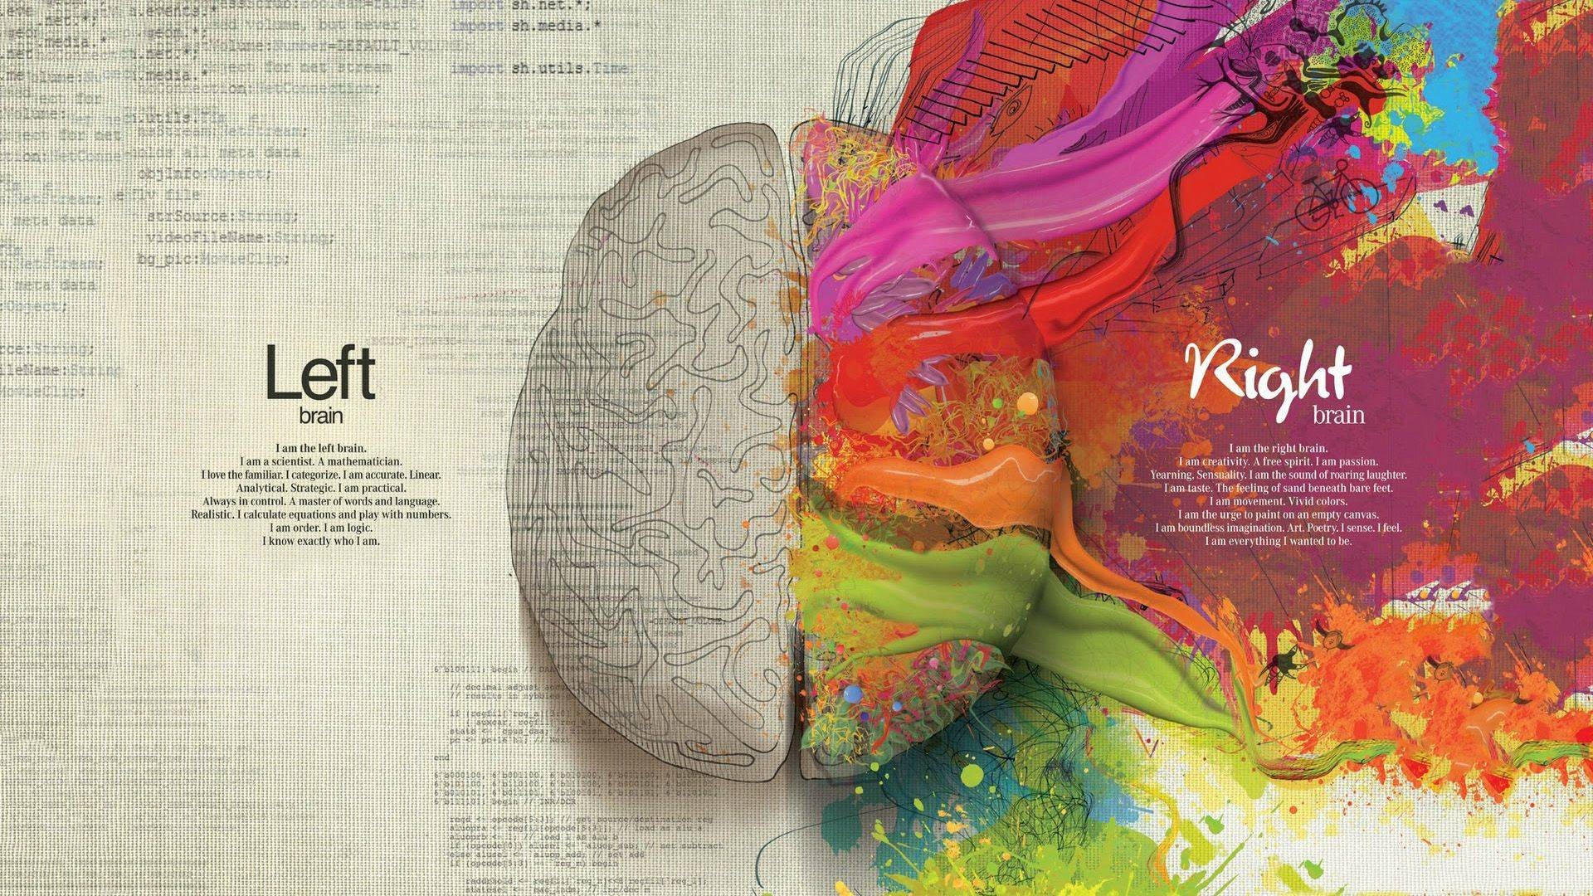

Since ancient times the power of the focused, concentrated, and clear mind has been elevated to godliness. The pursuit of self-knowledge and understanding is universally recognized in all cultures as a matter of utmost importance:

“Know thyself, and thou shalt know the universe and God.” - Inscription above the entrance to the temple of Apollo in Delphi.

“The mind is everything. What you think, you become.” - Gautama Buddha.

“If you know the enemy and know yourself, you need not fear the result of a hundred battles… Fear is the true enemy, the only enemy.” - Sun Tzu.

“The focused mind can pierce through stone.” - Japanese proverb.

“Looking behind, I am filled with gratitude, looking forward, I am filled with vision, looking upwards I am filled with strength, looking within, I discover peace.” - Quero Apache prayer.

“The battle is always within us. Any external conflict is a continuation of our own internal struggle. If we achieve inner peace, the battle will cease because the real enemy is already defeated.” - Anonymous.

… and many others.

As I mentioned at the very beginning of this text, the influence of our brain goes far beyond our own lives and changes everyone else who’s affected by our thoughts and actions. So you can imagine the difference we can make if we’re able to harness the power of will and direct it towards improving the conditions of our existence. But how do we achieve clarity and peace of mind? Many people claim to have the answer to that question with varying results. I will provide you with a meditation technique that I’ve personally tested and can confirm that it helped me numerous times to clear my thoughts and continue on the path I set for myself with enlightenment. You can try it and see if it has the same effect for you as well.

The first step is to remove any excess noise. We need to find or arrange a relatively quiet place where we can feel calm and be free of potential distractions (like other people, phones, computers, TV, radio, watches, etc.). We sit or lie down and relax our body, close our eyes and appreciate the lack of visual and auditory stimuli. We then imagine our compulsive thoughts, presumptions about ourselves, and brain clutter coming out of us as we exhale and leaving them to fall into a dark abyss from which there is no turning back. We let go of our emotional baggage and, in the process, become lighter and more aware of the present. At that moment, we can define ourselves by simply saying: “I exist,” without adding further meaning. To gain even greater self-awareness, we can focus on our hands, arms, face, torso, legs, feet and feel what each of them is feeling individually, reminding us of the control we have over our physical form and the processes inside it. Now that we are alone with ourselves in this heightened state of consciousness, we can finally turn inward and re-evaluate our current situation. We can reflect upon what we really expect from our life, what we strive to accomplish and bring out into the world, what qualities we want to attain or maintain, and what – to leave in the past. While examining our aspirations, we can also build a roadmap to achieve them. Believe it or not, our mind already knows the answers. The calculations and considerations that happen in the unconscious background of our brain far exceed our expectations. We just need to be open and ready to hear the truth about who we are, what our situation is, and what needs to be done to get where we want to be, as well as allow our mind to clearly express itself to us by removing the distractions both inside and outside so we can listen to our own reason.

It’s a relatively easy and practical method that helps us purify from negative thoughts, recover from the constant barrage of information we receive daily, and refocus on what is important to us. That way, we can continue with renewed clarity and strength after internally agreeing on the next logical steps that we need to take.

It’s important to mention that we should refrain from seeking guidance about matters that could potentially or intentionally cause harm to us or others. If we ask those questions, they will be answered as well. The fact that we know how to do something doesn’t mean that we should do it. Our actions have a ripple effect on society. It is the responsibility of each one of us to use our knowledge not to its detriment but for its benefit.

That brings me to another ability of our brain. One that reminds me a lot of alchemy and the property of the fabled Philosopher’s Stone to transmute base metals into silver and gold. We can take any negative thought or emotion and use our concentrated willpower to turn it into a driving force for improvement, success, and creativity. Sadness, anger, discontent, uncertainty, nostalgia, envy, stress – all of them can be transformed into motivation when given a positive purpose. For example, when I feel overwhelmed by frustration about circumstances I cannot change, I pour all the energy that is building up inside me into physical exercises or training in martial arts. That way, it is redirected towards my physical fitness. I’m no longer burdening myself and others around me with this unhealthy accumulation of negativity; instead, I’m taking advantage of it and making it work in my favor. My close ones also notice this positive change in my life and respond to it with encouragement. I learned to be thankful for what I receive, have control over my emotions, and metaphorically cleanse my destructive impulses by turning them into movements from a workout routine, which in turn makes my body, mind, and spirit stronger and more balanced. There are many other outlets for this transmutation – painting a picture, listening to or playing music, dancing, writing and telling stories, playing games, fueling our creativity, or building a plan to overcome the situation that causes these emotions to begin with.

Of course, we could achieve all of this through positive reinforcement as well. Great deeds can be accomplished in the name of being happy, seeing the beauty in the world, feeling curiosity, a sense of belonging, love, and gratitude.

I used a bit of both sources of motivation to persevere and create this labor of love in hopes that it will resonate with you and help set in motion the shift towards a brighter future and greater understanding of our connection with the world - a more mature and caring society.

Epilogue

Imagine that you wake up without an alarm, driven only by your need to move, live, discover, express or improve yourself. Your home is located wherever you feel the most comfortable – in a hot, cold, or moderate climate, ground level or way above it, in the plains, high into the mountains, at the seaside, or even on water. You have plenty of food and drinks based on your unique dietary needs, clean water and air, clothes tailored specifically for you, any item you may require to do what makes you happy, as well as an abundance of renewable energy sources to power your devices and residence. You are in good health and with the mindset of a problem-solver, free to go wherever you wish and take on any challenge life throws at you. Your thoughts are clear of politics or propaganda since your allegiance is to the whole world and humankind. The only religion that influences your life is the one you choose of your own free will. As a society, we can take care of everyone not because we all have money but because we are technologically and morally advanced to that point. Currency and artificial value are no longer necessary since we’ve outgrown their use. Goods and services meet or exceed people’s demands through proper resource management. We have realized and accepted our interconnection with everyone and everything else in the world. We understand that our true responsibilities lie with finding our vocation, respecting and not harming others, seeking to constantly improve ourselves and the whole of humankind in peaceful ways, recycling any item that we don’t need so others can use it. You are free to learn and practice in any creative field you desire with no “better” or “worse” jobs, only a duty to yourself to discover your greatest talents and strengths, develop and apply them for the benefit of all, as well as impart your knowledge to the next generations when you are ready for it.

We truly have this remarkable potential for a future society, and we already have the tools and blueprints to achieve it. We only need to will it into existence by carefully taking the necessary steps to make it happen one by one, as well as agreeing to allow ourselves and each other a more acceptable way of life. It is time for every one of us to decide whether to turn our backs on these ideas, artificially divided, conquered and accepting a lower state of existence, or to prefer them to the existing system, opening our minds and insisting to see how this change takes root in our world through every action we take to realize it. If we choose the second option, we will bravely set off towards more clarity and a greater understanding, finding our true place in the community and realizing that there is no such thing as perfection because everything and everyone is in a constant state of change.

When we resolve all these matters and achieve a sustainable international society in our own home - the Earth - we will finally be able to call ourselves civilized in good conscience. Such a tremendous achievement will serve as a foundation for even greater discoveries. It will allow us to spread our wings and turn our gaze towards the stars.

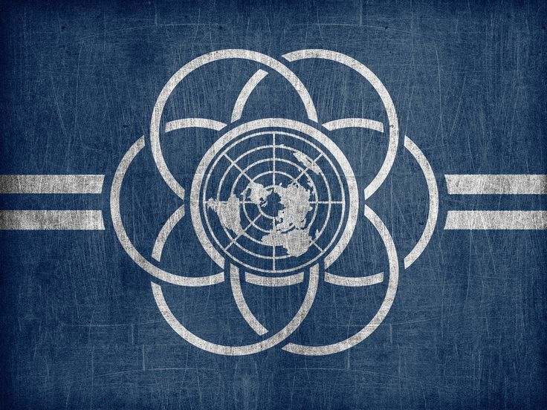

The International Flag of Planet Earth, designed by Oskar Pernefeldt in 2015

Sources:

<https://www.theworldcounts.com/challenges/people-and-poverty/hunger-and-obesity/how-many-people-die-from-hunger-each-year> - Worldwide statistics for yearly deaths from hunger

<https://okm.fi/en/frontpage> ; <https://www.youtube.com/watch?v=7xCe2m0kiSg> - The Finnish education system

<https://www.youtube.com/watch?v=P20l0eQIbqg> - The Secret and the Law of Attraction

<https://www.youtube.com/watch?v=LPhANpsR1gM> - Zeitgeist - The Movie

<https://www.youtube.com/watch?v=5uUA2wTBblo> - Zeitgeist Moving Forward

<https://www.youtube.com/watch?v=I1IXWnS6vwk&t=2230s> - Future by Design

<https://www.thetemples.org/temples/> - Temples of Humankind

<https://www.thevenusproject.com/the-venus-project/> ; <https://www.youtube.com/c/TheVenusProjectGlobal/videos> - The Venus Project

<https://all3dp.com/> - 3D printing basics

<https://gfi.org/science/the-science-of-cultivated-meat/> - Information on cultured meat

<https://www.youtube.com/watch?v=mKCVol2iWcc> – Cooking robot

<https://www.verticalroots.com/the-what-and-why-of-hydroponic-farming/> - Hydroponic farming

<https://solarroadways.com/> - Solar roadways

<https://www.iter.org/> - ITER

<https://www.youtube.com/watch?v=sLCHg9mUBag&t=38s> – presentation of EPCOT

<https://www.youtube.com/watch?v=_-3lGMjnGi0> ; <https://www.youtube.com/watch?v=F_brnKz_2tI> – Mind-controlled prosthetics

<https://en.wikipedia.org/wiki/Self-driving_car> ; <https://eu.usatoday.com/story/tech/2022/08/29/self-driving-cars-future-gm-tesla/7896389001/> ; <https://www.tusimple.com/> - Information on self-driving vehicles

<https://www.bhaptics.com/> ; <https://teslasuit.io/> ; <https://www.axon.com/training/vr> - Haptic suits

<https://www.youtube.com/watch?v=sCZt2YipiIs> ; <https://www.kriminalomsorgen.no/informasjon-paa-engelsk.536003.no.html> - Correctional facilities in Norway

<https://turkisharchaeonews.net/museum/health-museum-edirne> - Health museum in Edirne

<https://www.medicalnewstoday.com/articles/psychedelic-therapy#uses-and-benefits> – Studies on medical uses of psychedelics

<https://en.wikipedia.org/wiki/Airsoft> - Airsoft